**Book conventions**

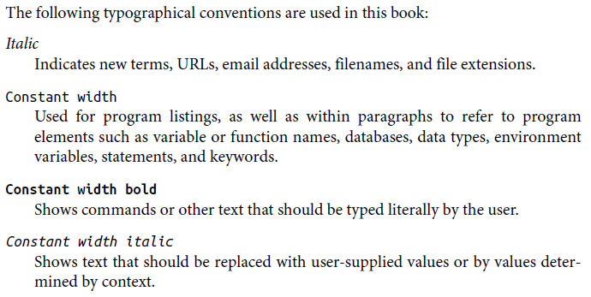

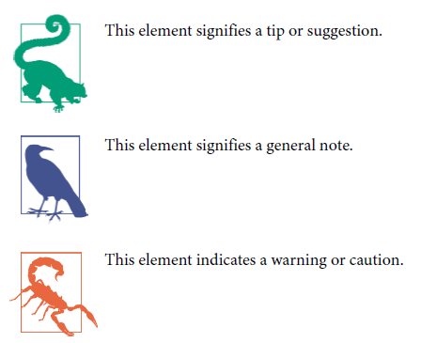

**Vinculum (repeating bar)**

A vinculum can indicate the repetend of a repeating decimal value:



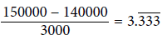 = 3.3333333333333…

In other words it indicates that the digits or fractions are repeating infinitely.

**Order of operations**

**PEMDAS**: parentheses, exponents, multiplication, division, addition, and subtraction

**Expressing dependent and independent variables in a function**

You can use *y = 2x + 1* or *f(x) = 2x + 1* to express the dependent variable *y* as a function of *x*.

If you have *two independent variables* you write the function like *f(x, y) = 2x + 3y*. In this function two independent variables *x* and *y* and one dependent variable the output of *f(x, y)*. The graph of this function will be plotted on three dimensions to produce a plane of values rather than a line.

**Cartesian plane, x-y plane, coordinate plane**

When we plot on a two-dimensional plane with two number lines (one for each variable) it is known as a *Cartesian plane*, *x-y plane*, or *coordinate plane*. По-русски: *прямоугольная система координат* или *Декартова система*. We trace a given x-value and then look up the corresponding y-value, and plot the intersections

as a line.

Example of a Cartesian plane:

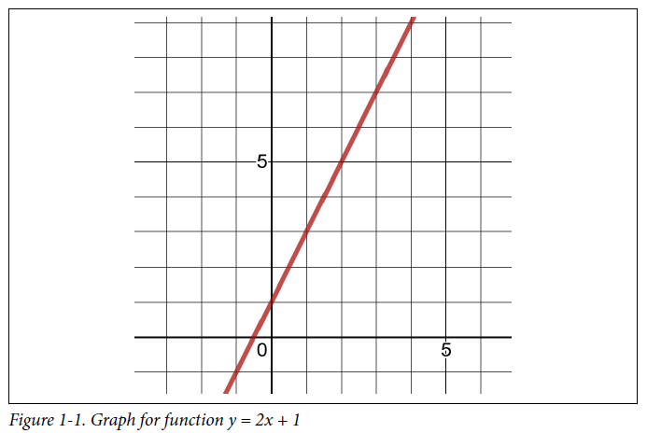

Notice that due to the nature of real numbers (or decimals, if you prefer), there are an infinite number of x values. This is why when we plot the function f(x) we get a continuous line with no breaks in it. There are an infinite number of points on that line, or any part of that line.

**Straight-line function / straight-line graph**

This is a straight-line *f(x) = 2x + 1*:

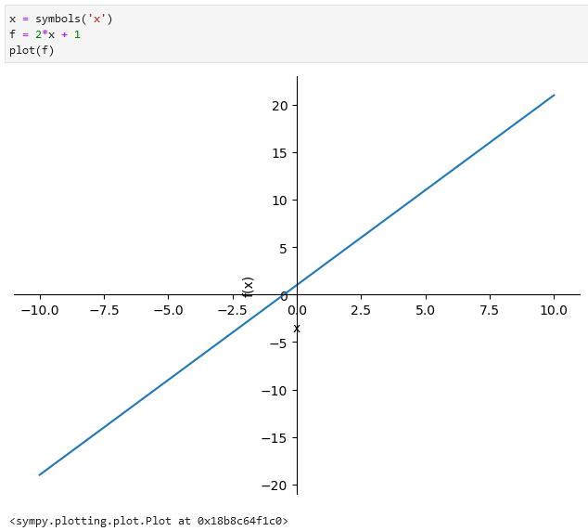

**Parabola function / parabola graph**

This is a parabola *f(x) = x2 + 1*:

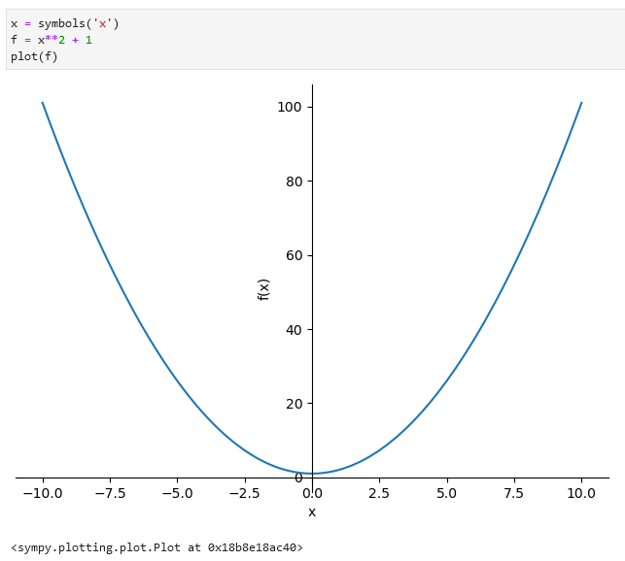

It is continuous but not linear. It does not produce values in a straight line. When a function is continuous but curvy, rather than linear and straight, we call it a *curvilinear function*.

**Summation symbol sigma Σ**

If I want to iterate the numbers 1 through 5, multiply each by 2, and sum them, here is how I would express that using a summation

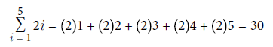





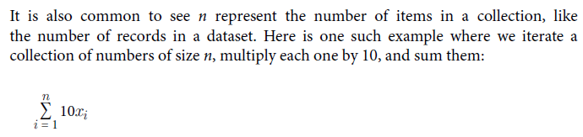

**Exponents**

23 2 is the base and 3 is the exponent (number of times 2 should be multiplied by 2: 2 * 2 * 2)

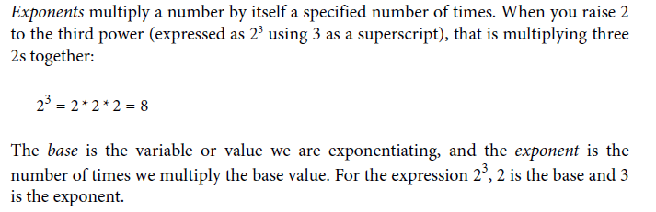

When we multiply exponents together with the same base, we simply add the exponents, which is known as the *product rule*:

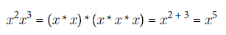

Division:

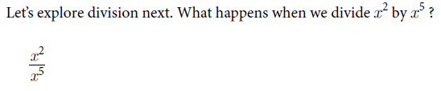

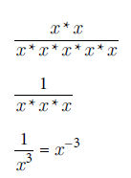

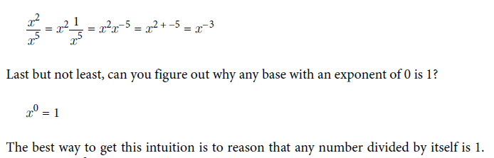

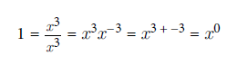

**Roots**

A 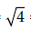 asks “What number multiplied by itself will give me 4?” which of course is 2. Note here that 41/2 is the same as 4:

41/2 =  = 2

Cubed roots are similar to square roots, but they seek a number multiplied by itself three times to give a result. A cubed root of 8 is expressed as 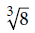 and asks “What number multiplied by itself three times gives me 8?” This number would be 2 because 2 * 2 * 2 = 8.

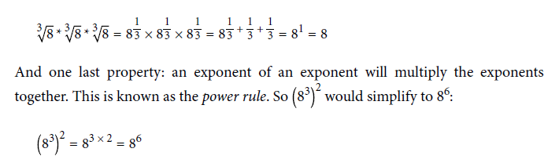power rule

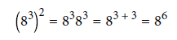

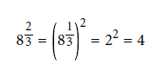

**Logarithms *log()***

A logarithm is a math function that finds a power for a specific number and base.

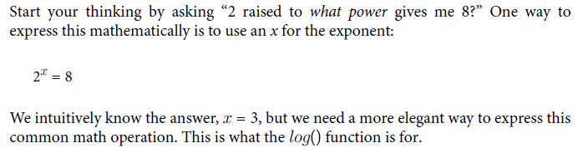

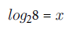

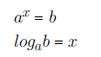

Algebraically speaking, this is a way of isolating the *x*, which is important to solve for *x*.

**Properties for exponents and logarithms**

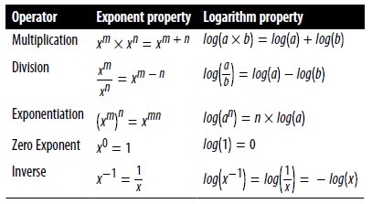

**Natural logarithms *log() ln()***

When we use *e* as our base for a logarithm, we call it a *natural logarithm*.

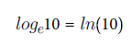

However, in Python, a natural logarithm is specified by the log() function. As discussed earlier, the default base for the log() function is *e*. Just leave the second argument for the base empty and it will default to using *e* as the base

**Function that approaches 0 but never reaches 0 *lim***

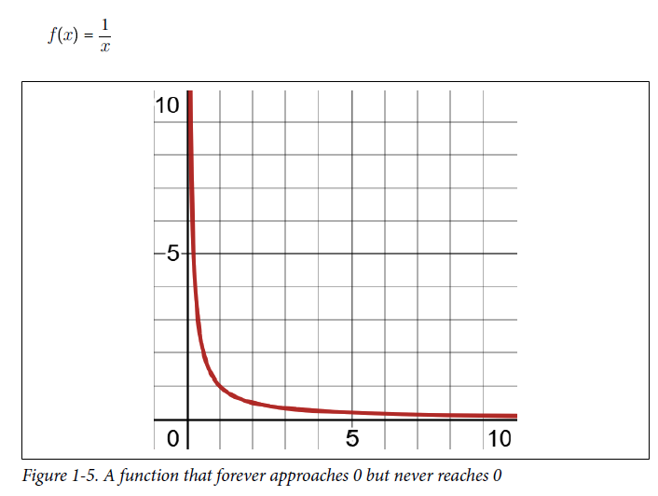

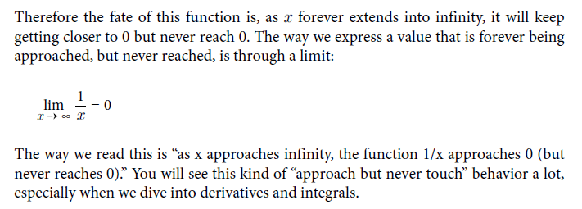

**Derivatives**

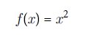

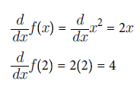

Calculate derivative in SymPy:

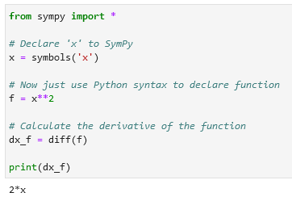 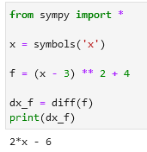

**Partial derivatives**

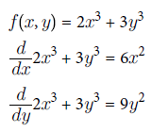

**The chain rule**

Finding the derivative of *z* with respect to *x*:

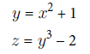 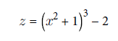 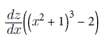 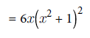

This is the chain rule, which says that for a given function *y* (with input variable *x*) composed into another function *z* (with input variable *y*), we can find the derivative of *z* with respect to *x* by multiplying the two respective derivatives together:

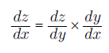

The chain rule is a key part of training a neural network with the proper weights and biases. Rather than untangle the derivative of each node in a nested onion fashion, we can multiply the derivatives across each node instead, which is mathematically a lot easier.

**Integrals**

The opposite of a derivative is an integral, which finds the area under the curve for a given range.

Packing rectangles under a curve to approximate area:

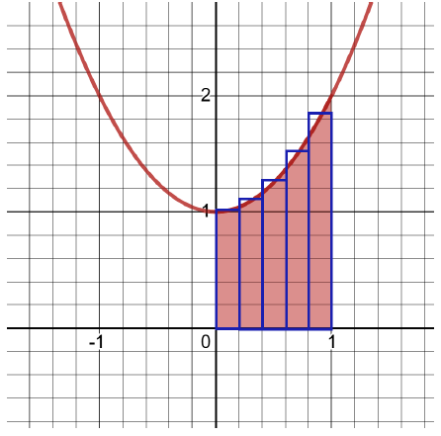

**Riemann sums**

Khan Academy has a great [article](https://www.khanacademy.org/math/ap-calculus-ab/ab-integration-new/ab-6-3/a/definite-integral-as-the-limit-of-a-riemann-sum) explaining how to use limits for Reimann Sums.

**Probability**

Probability is how strongly we believe an event will happen, often expressed as a percentage.

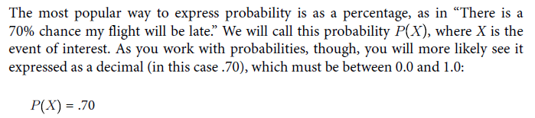

**Probability** is about quantifying predictions of events yet to happen, whereas **likelihood** is measuring the frequency of events that already occurred. In statistics and machine learning, we often use **likelihood** (the past) in the form of data to predict **probability** (the future).

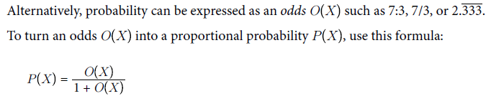

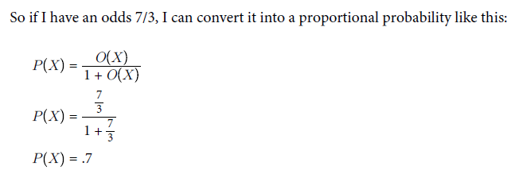

Convert probability into odds:

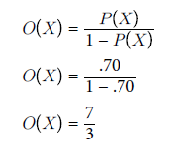

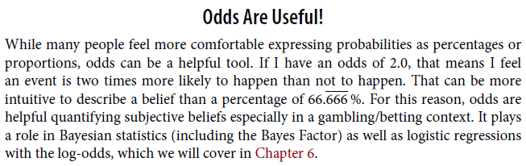

Probability is purely theoretical of how likely an event is to happen and does not require data. Statistics, on the other hand, cannot exist without data and uses it to discover probability and provides tools to describe data.

Think of predicting the outcome of rolling a 4 on a die (that’s the singular of dice). Approaching the problem with a pure probability mindset, one simply says there are six sides on a die. We assume each side is equally likely, so the probability of getting a 4 is 1/6, or 16.666%. However, a zealous statistician might say, “No! We need to roll the die to get data. If we can get 30 rolls or more, and the more rolls we do the better, only then will we have data to determine the probability of getting a 4.” This approach may seem silly if we assume the die is fair, but what if it’s not? If that’s the case, collecting data is the only way to discover the probability of rolling a 4.

**Marginal probability**

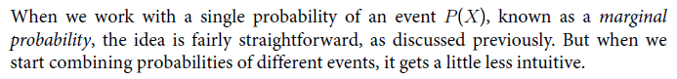

**Joint probability**

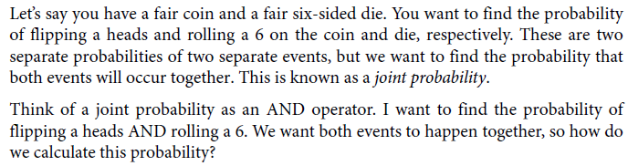

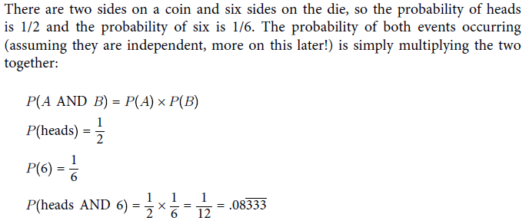

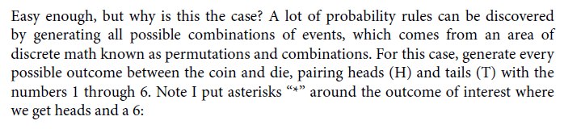

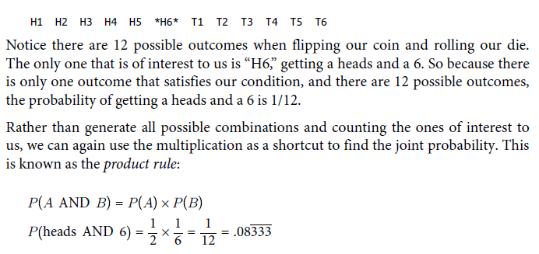

**Union probability**

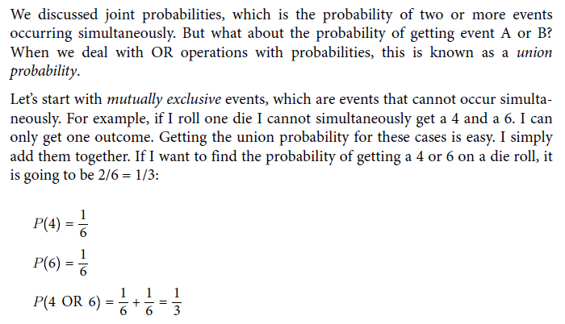

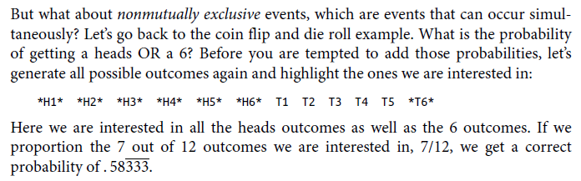

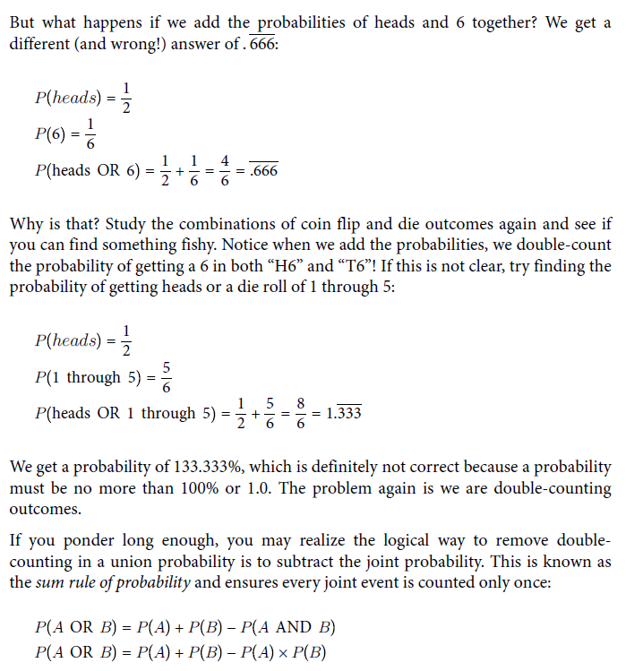

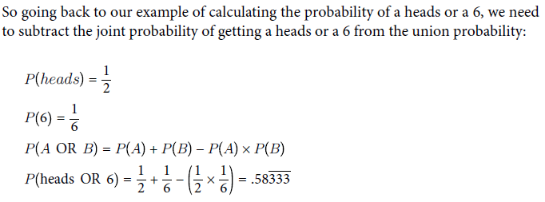

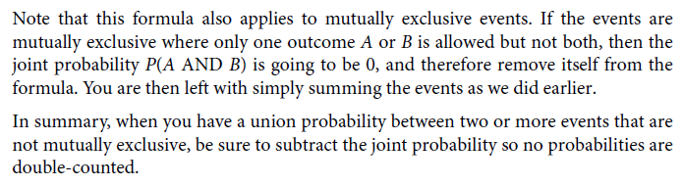

**Conditional Probability and Bayes’ Theorem**

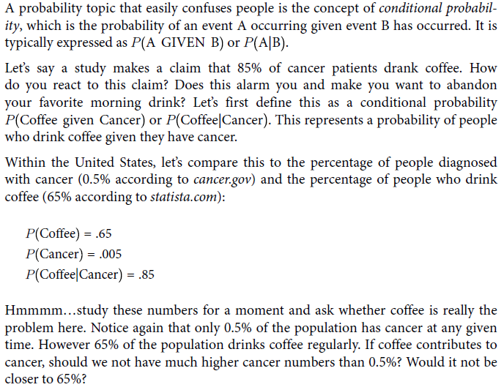

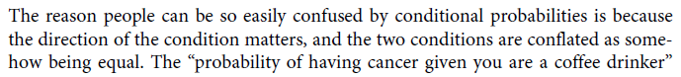

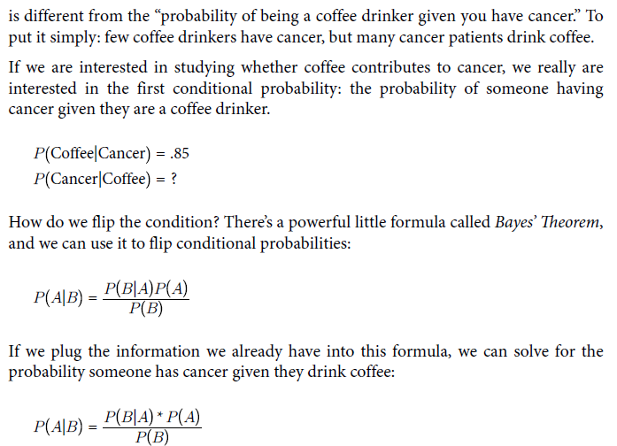

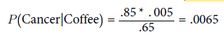

**Joint and union conditional probabilities**

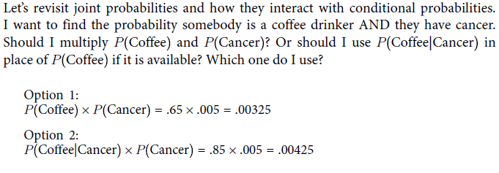

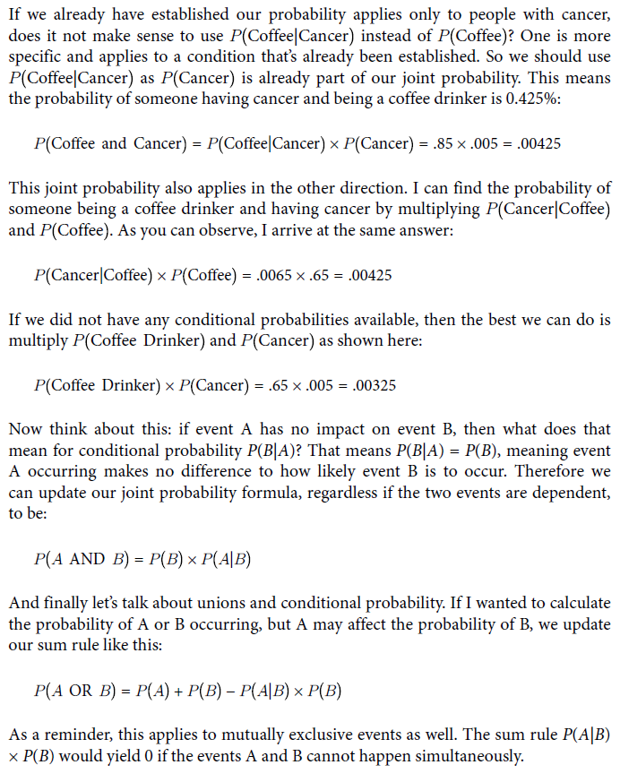

**Binomial Distribution**

Binomial distribution measures how likely *k* successes can happen out of *n* trials given *p* probability. Visually it looks like:

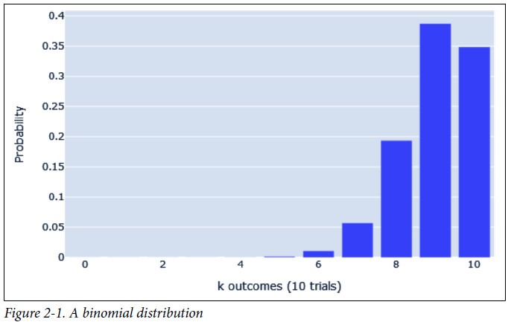

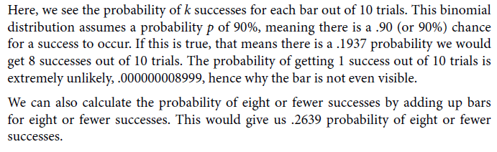

**Beta T-Distribution**

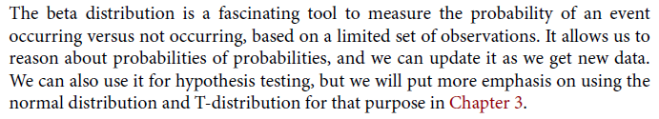

**Descriptive and Inferential Statistics**

**Descriptive statistics: we have data and we summarize it.**

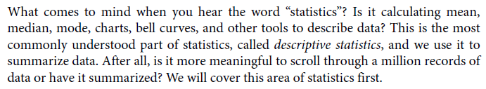

**Inferential statistics: based on a sample look for attributes of a larger population.**

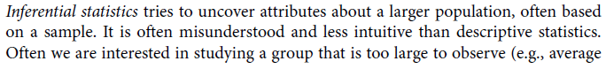

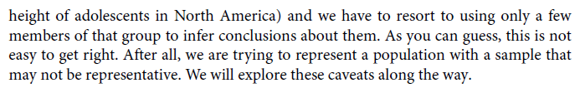

**Self-selection bias:**

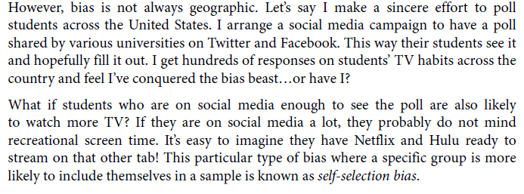

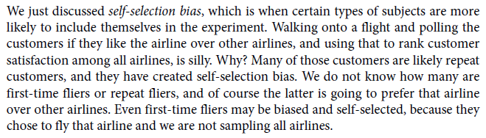

**Confirmation bias:**

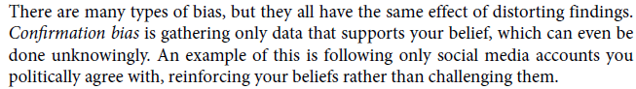

**Survival bias:**





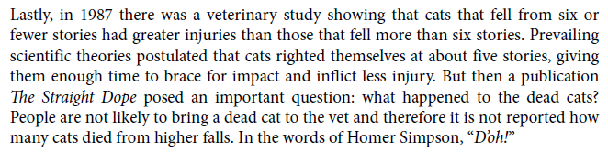

**Mean**

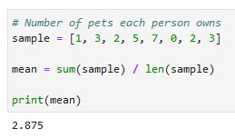

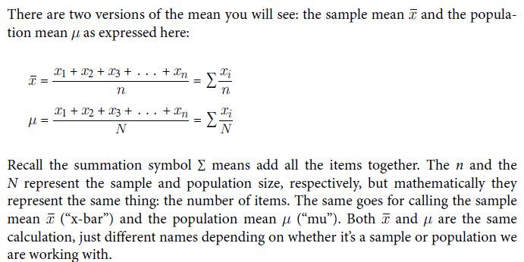

**Weighted mean**

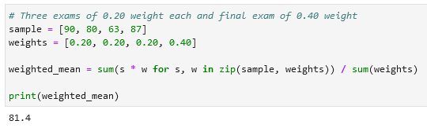

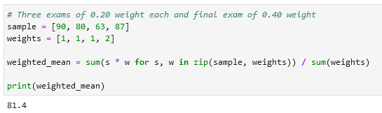

**Median**

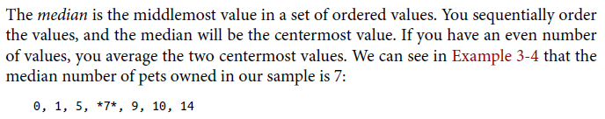

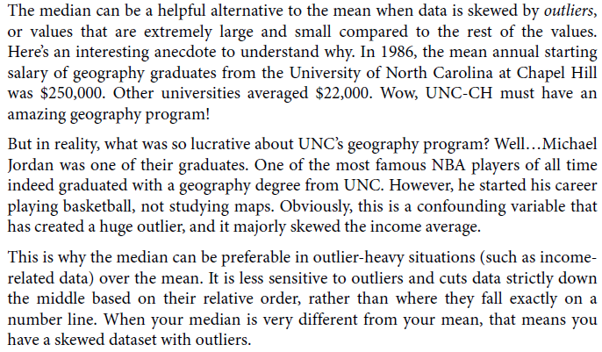

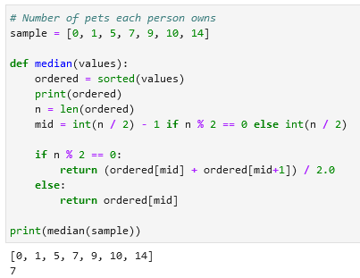

**Quantiles**

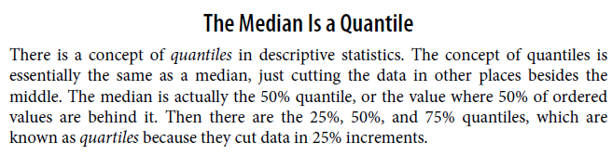

**Mode**

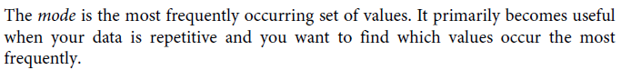



Calculate mode (use functions like from collections import defaultdict(lambda: 0):

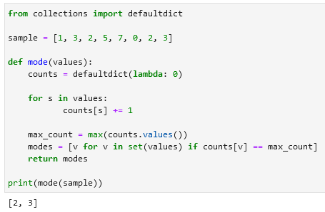

A defaultdict is a dictionary-like object that allows you to set a default value for keys that don't exist in the dictionary. This can be especially useful when you're counting occurrences of elements, like in your mode function.

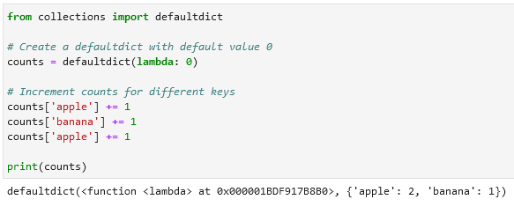

**Population variance and standard deviation**

**Population variance**

Variance is a measure of how spread out our data is.

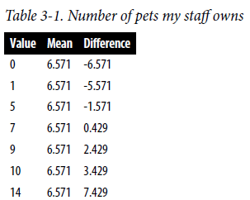

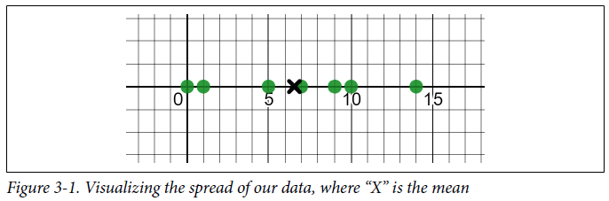

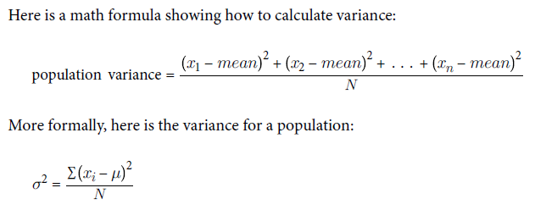

**Calculate variance:**

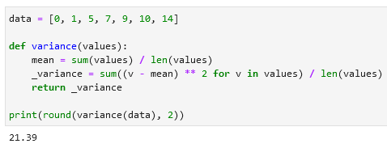

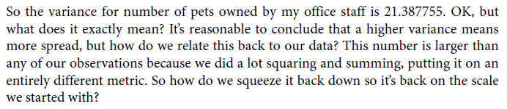

**Population standard deviation**

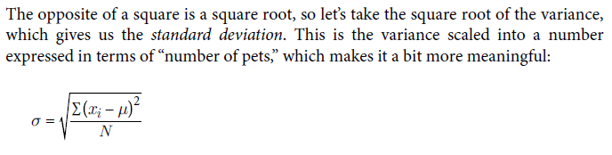

**Calculate** *population* **standard deviation:**

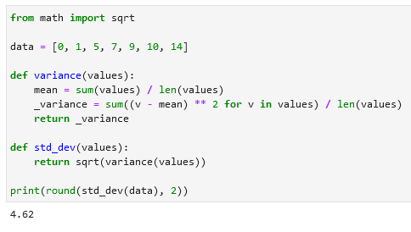

**Sample variance and standard deviation**

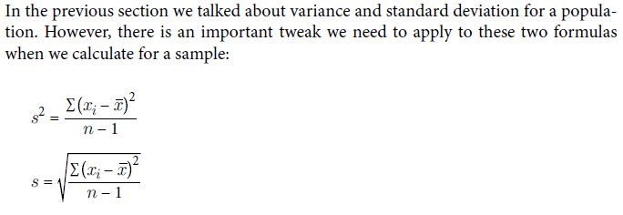

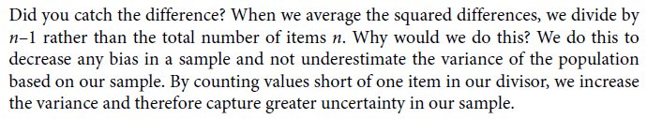

**Calculate sample variance and sample standard deviation:**

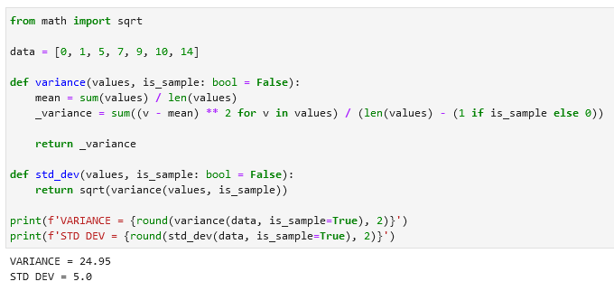

Both variance and standard deviation have increased when we treated them as a population and not a sample. This is correct as a sample could be biased and imperfect representing the population. Therefore, we increase the variance (and thus the standard deviation) to increase our estimate of how spread out the values are. A larger variance/standard deviation shows less confidence with a larger range.

**The Normal Distribution**

We touched on probability distributions in the last chapter, particularly the binomial distribution and beta distribution. However the most famous distribution of all is the normal distribution. The normal distribution, also known as the Gaussian distribution, is a symmetrical bell-shaped distribution that has most mass around the mean, and its spread is defined as a standard deviation. The “tails” on either side become thinner as you move away from the mean.

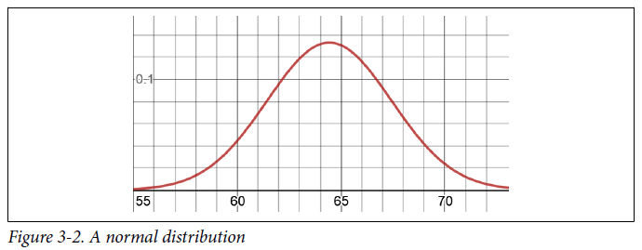

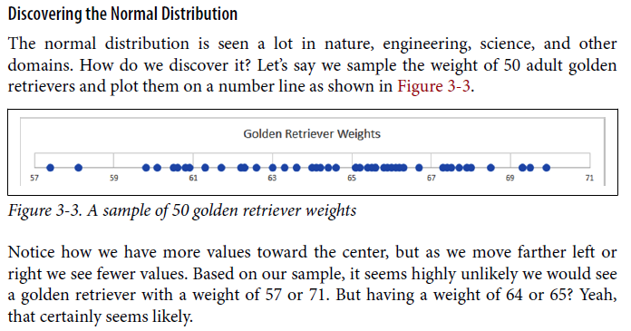

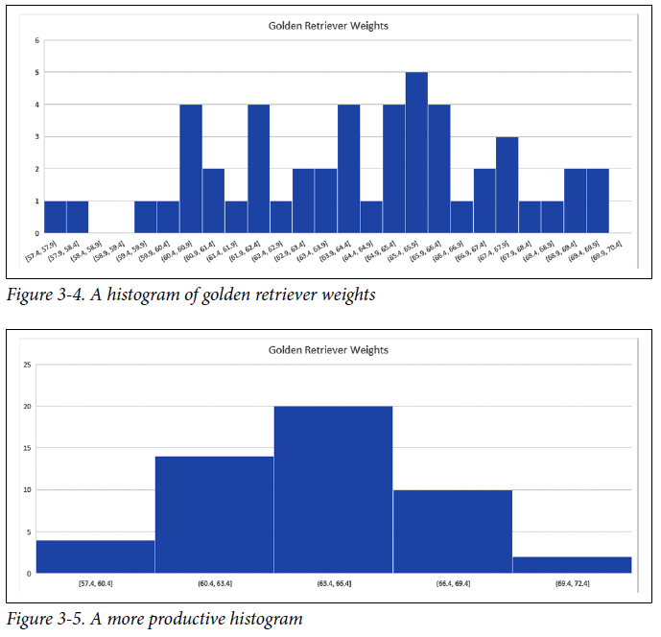

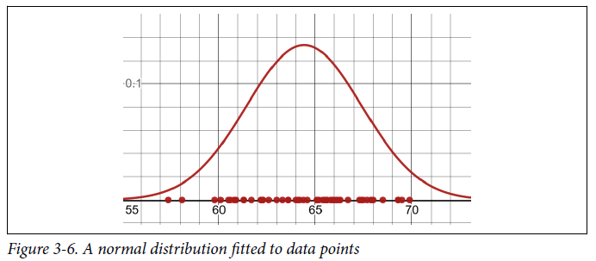

**Properties of a normal distribution**

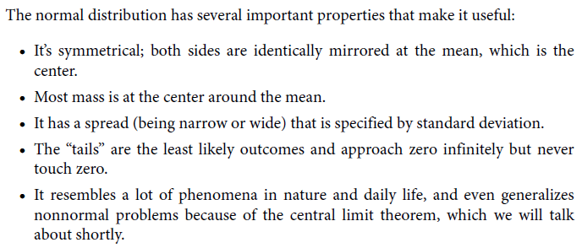

**The Probability Density Function (PDF)**

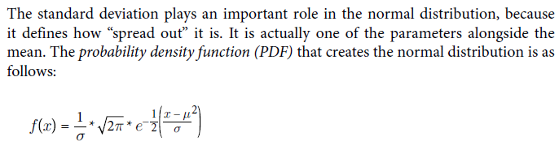

The correct formula is ([from](https://en.wikipedia.org/wiki/Probability_density_function)):

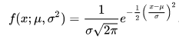

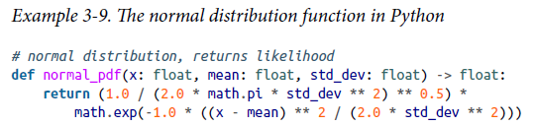

**The Cumulative Distribution Function (CDF)**

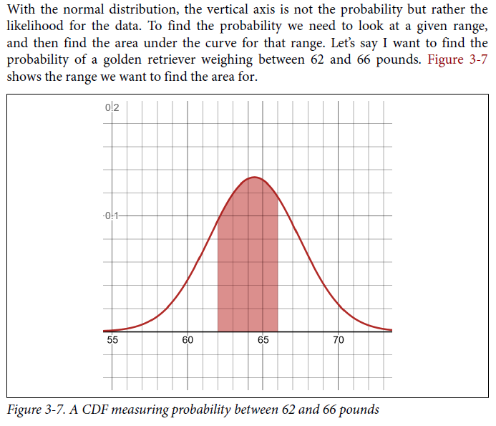

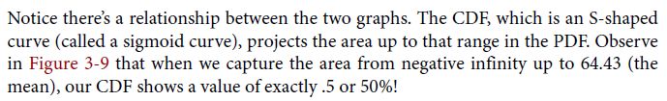

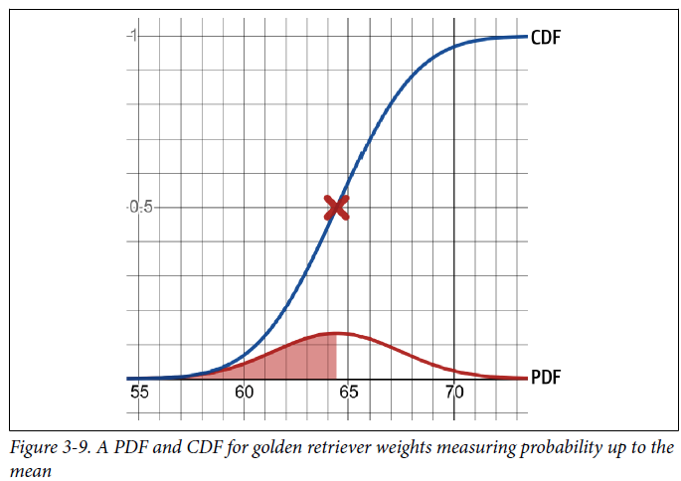

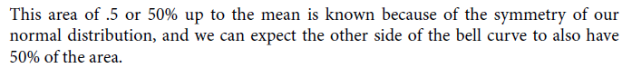

**Calculate the normal distribution CDF in Python using scipy.stats and norm.cdf:**

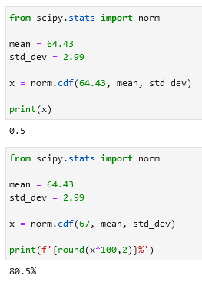

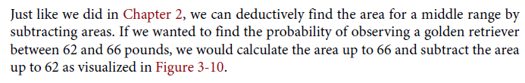

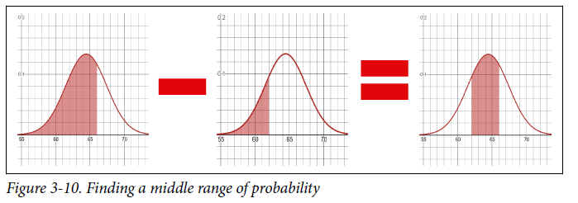

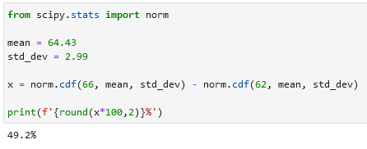



**The Inverse CDF**

You can use it to find *x*. For example if you want to *find the weight that 95% of golden retrievers fall under*.

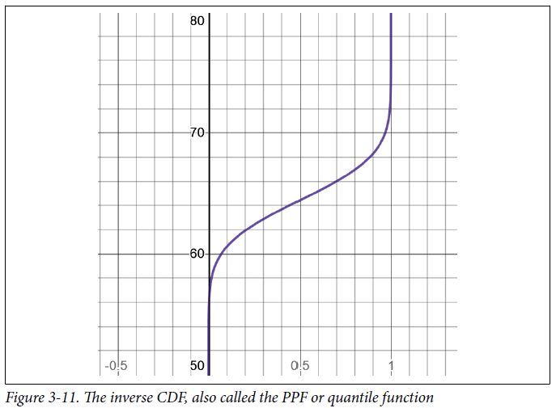

Calculate the inverse CDF (or norm.ppf):

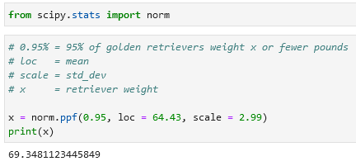

You can use inverse CDF to generate random numbers that follow the normal distribution. For example, if you want to generate 10 realistic cat weights you can use this code:

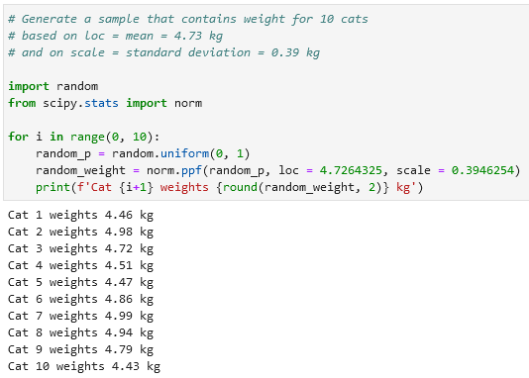

Of course NumPy and other libraries can generate random values off a distribution for you, but this highlights one use case where the inverse CDF is handy.

**Z-Scores**

It is common to rescale a normal distribution so that the mean is 0 and the standard deviation is 1, which is known as the standard normal distribution. This makes it easy to compare the spread of one normal distribution to another normal distribution, even if they have different means and variances.

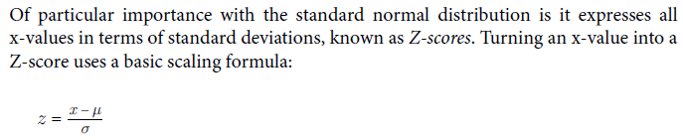

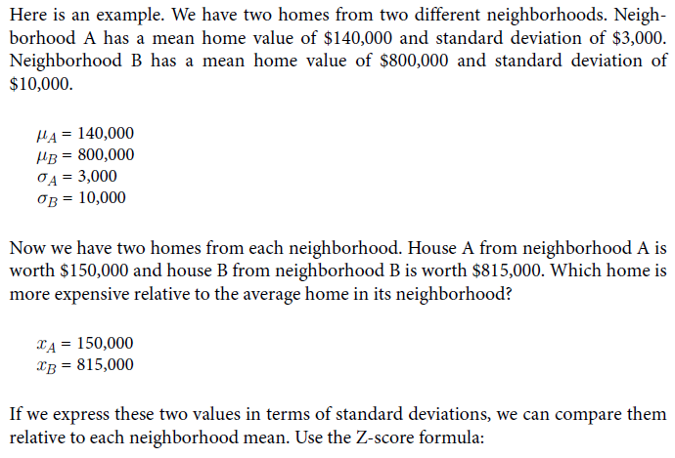

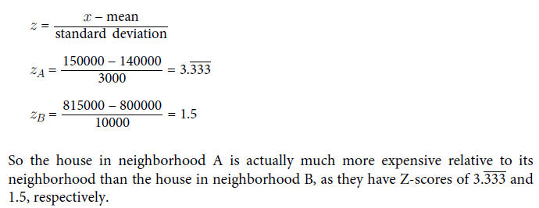

**Calculate the Z-Score in Python:**

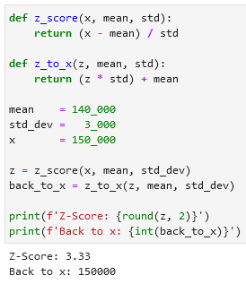

**Coefficient of Variation**

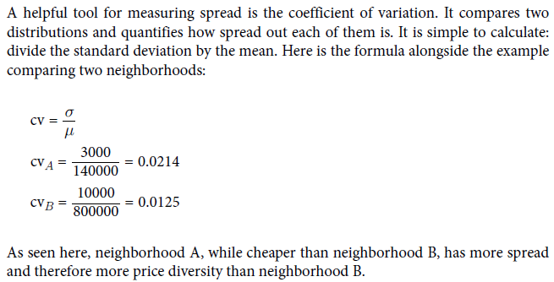

**Inferential statistics**

**Central Limit Theorem**

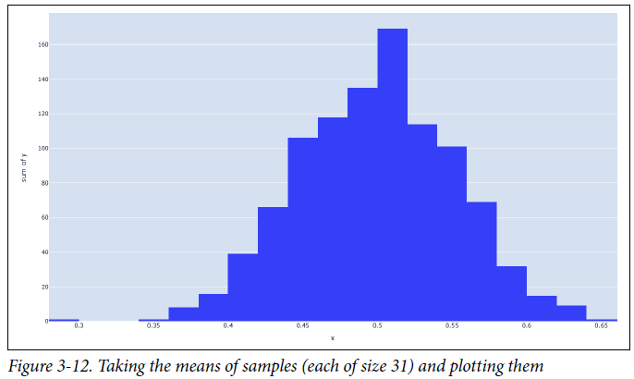

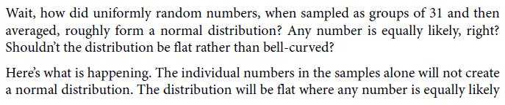

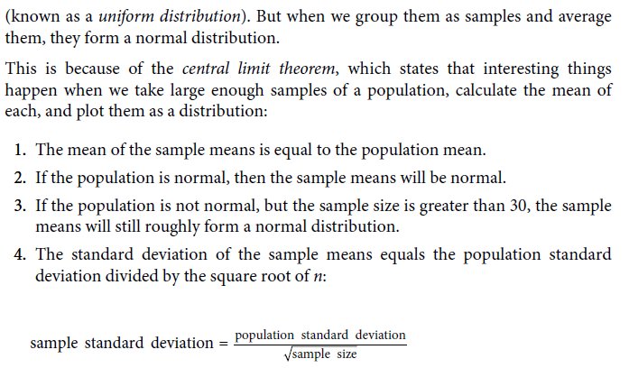

uniform distribution

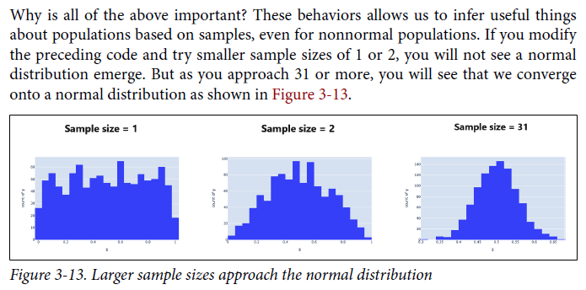

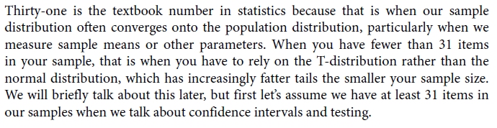

**How much sample is enough?**

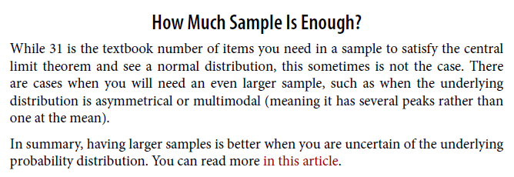

**Asymmetrical or multimodal distribution**

Distribution is asymmetrical or multimodal means that it has several peaks rather than one at the mean.

[**The Central Limit Theorem: What’s Large Enough**](https://www.dummies.com/article/academics-the-arts/math/statistics/the-central-limit-theorem-whats-large-enough-142651/)

In a nutshell, the Central Limit Theorem says you can use the normal distribution to describe the behavior of a sample mean even if the individual values that make up the sample mean are not normal themselves. But this is only possible if the sample size is “large enough.” Many statistics textbooks would tell you that n would have to be at least 30.

But why is n = 30 the benchmark? Many variables in nature, finance, and other applications have a distribution that’s very close to the normal curve. For example, by looking at the t-table, you see that the various values of t start to get really close to the values of z by the time you hit about 30 degrees of freedom. One reason for this is that the t-distributions and the normal distribution share two important characteristics: They are symmetric, and they are unimodal (having one peak).

If the distribution of your individual data values is far off from either of these qualities, you might need more than a sample size of 30 to use the Central Limit Theorem. The further away the data is from being symmetric and unimodal, the more data you’ll need.

## **Symmetry**

If you know or suspect that your parent distribution is not symmetric about the mean, then you may need a sample size that’s significantly larger than 30 to get the possible sample means to look normal (and thus use the Central Limit Theorem).

Consider the following right-skewed histogram, which records the number of pets per household.

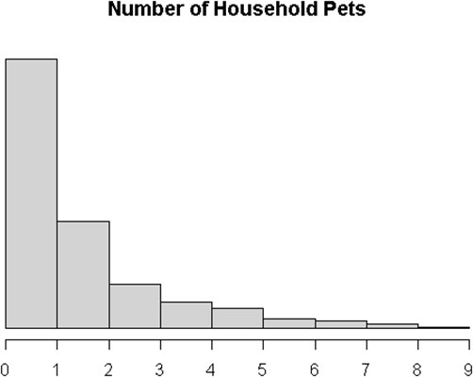

Now, suppose it represents the entire population of households. You repeatedly sample *n* = 30 households from that population. Here is what distribution of possible sample means looks like.

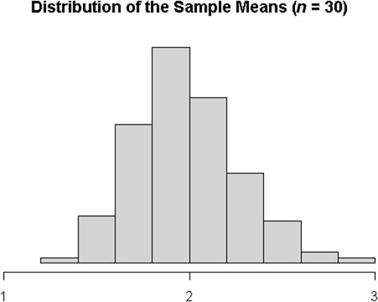

You can see that this distribution is not normal because the right tail still stretches out farther from the central peak than the left tail does. It’s not symmetric. For this population, you need to take a sample of around *n* = 100 to get the sample means to settle into a symmetric curve.

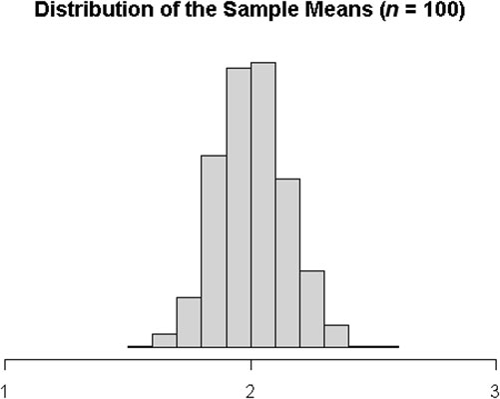

## **Unimodal**

If you know or suspect that your parent distribution is not unimodal and has more than one peak, then you might need more than 30 in your sample to feel good about using the Central Limit Theorem.

Consider the following multimodal population histogram with three distinct peaks.

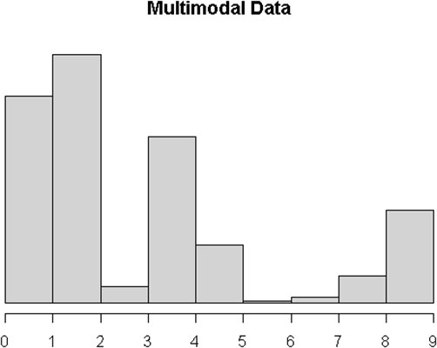

If you only sample *n* = 30 from that population, you do get a unimodal distribution, but it’s still not quite symmetric.

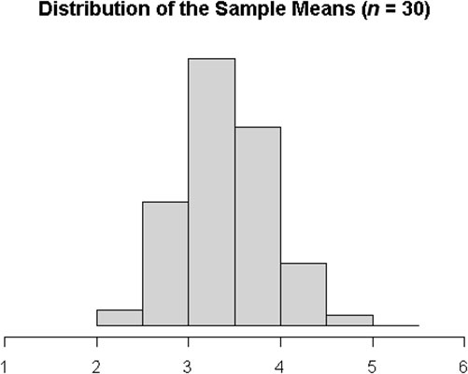

For this population, you need to take a sample of at least *n* = 50 to feel comfortable that your sample mean distribution is roughly normal.

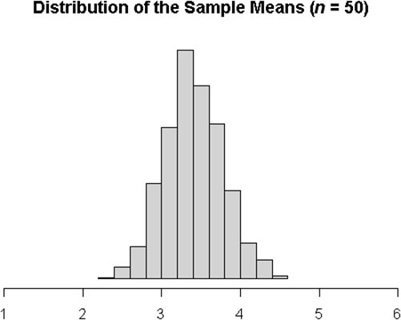

**Confidence Intervals**

A confidence interval is a range calculation showing how confidently we believe a sample mean (or other parameter) falls in a range for the population mean.

**For example:**

* *Based on a* ***sample of 31*** *golden retrievers*
* *with a* ***sample mean of 64.408***
* *and a* ***sample standard deviation*** *of* ***2.05****,*
* *I am* ***95% confident***
* *that the* ***population mean*** *lies* ***between 63.686 and 65.1296****.*

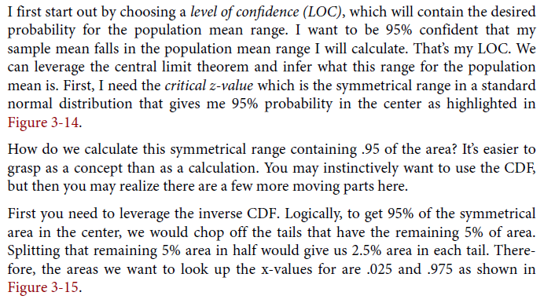level of confidence (LOC)

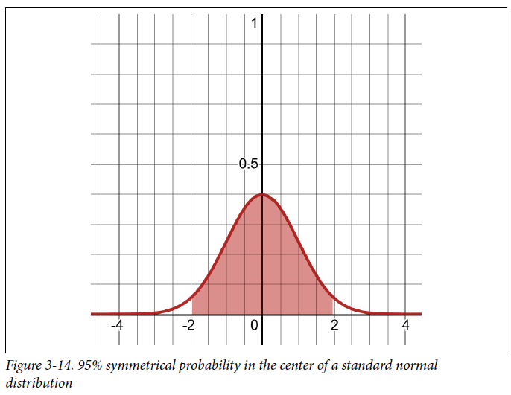

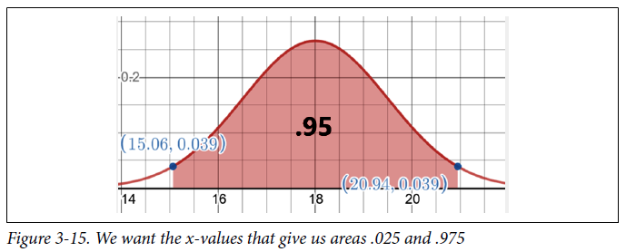

**Retrieve a critical z-value in Python:**

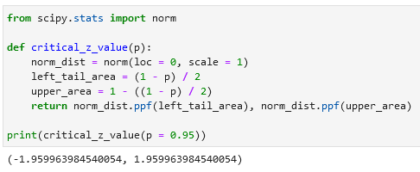

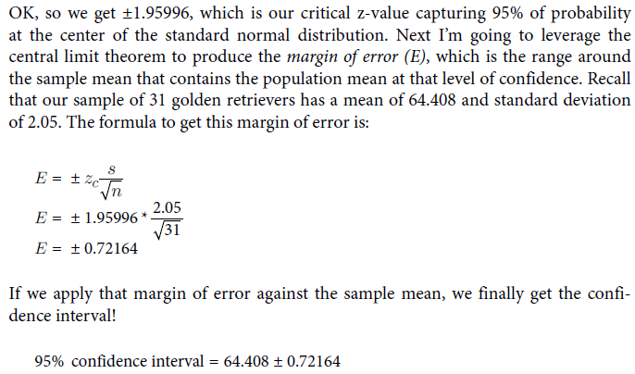margin of error (E), confidence interval

**Calculate confidence intervals in Python (example 1):**

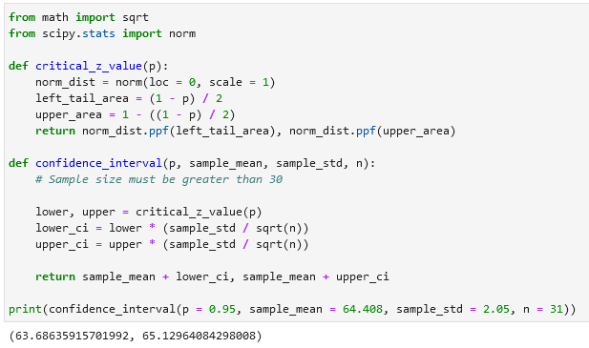

**Calculate confidence intervals in Python (example 2):**

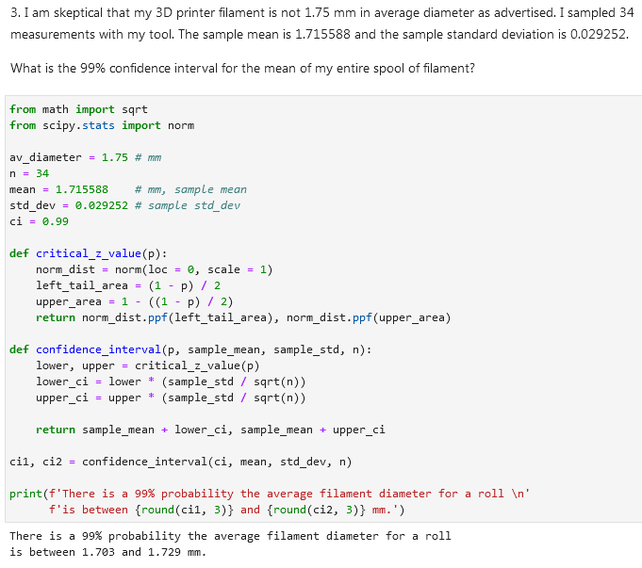

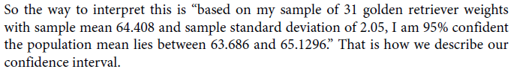

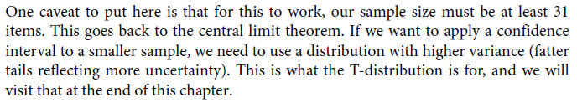

**P-values**

When we say something is *statistically significant*, what do we mean by that? Technically, it has to do with something called the *p-value*.

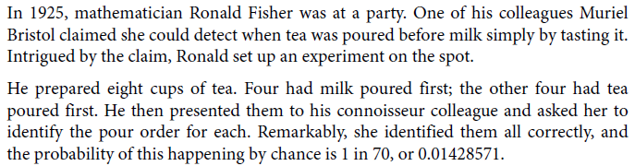

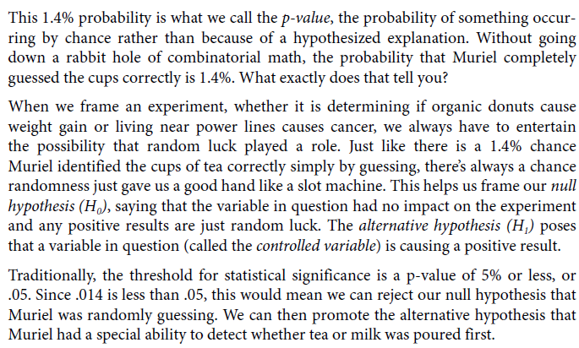

**Hypothesis Testing**

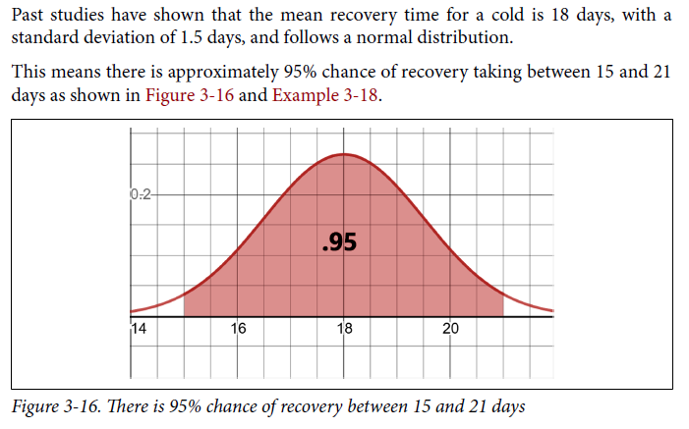

Calculate the probability of recovering between 15 and 21 days:

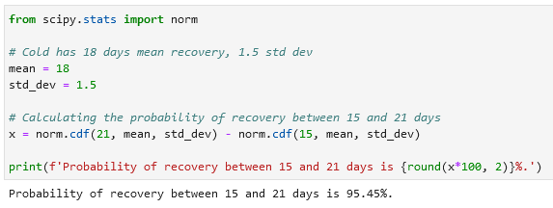

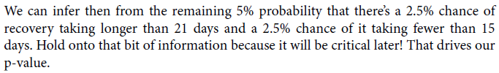

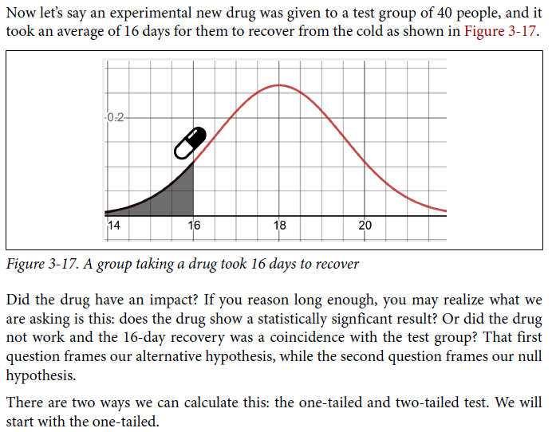

**One-Tailed Test**



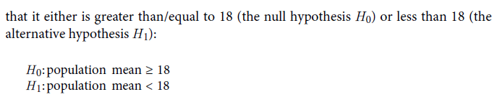

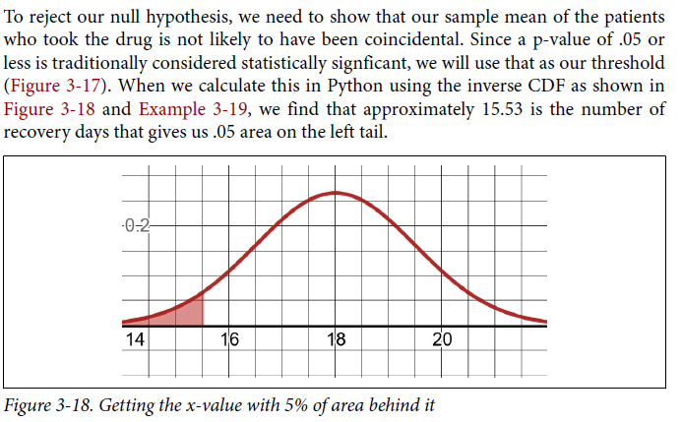

Calculate the x-value with 5% of area behind it in Python using inverse CDF or norm.ppf:

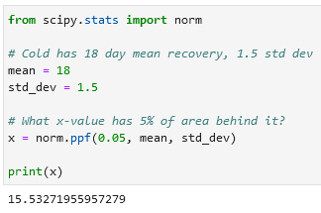

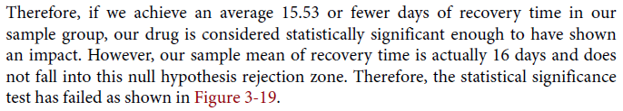

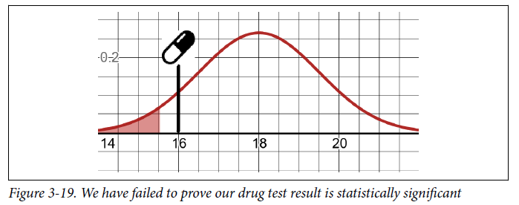



Calculate the p-value in Python using norm.cdf:

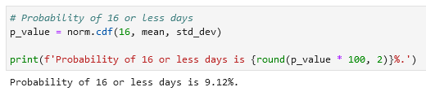



**Two-Tailed Test**

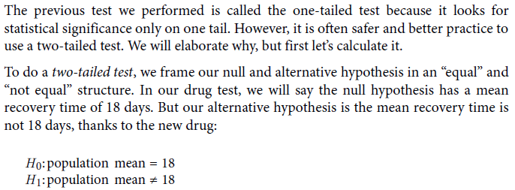

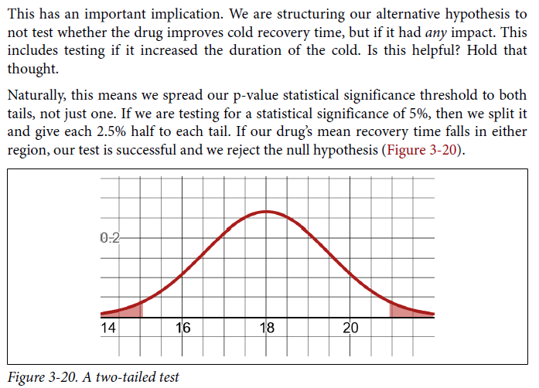

**Two-tailed test in Python:**

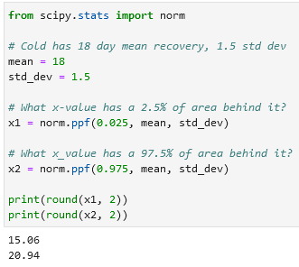

Example 2:

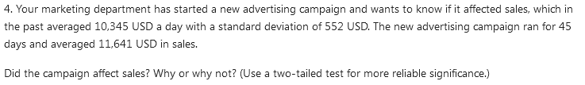

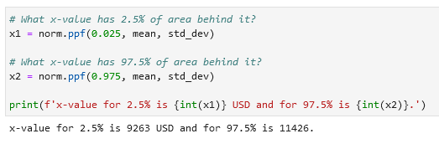

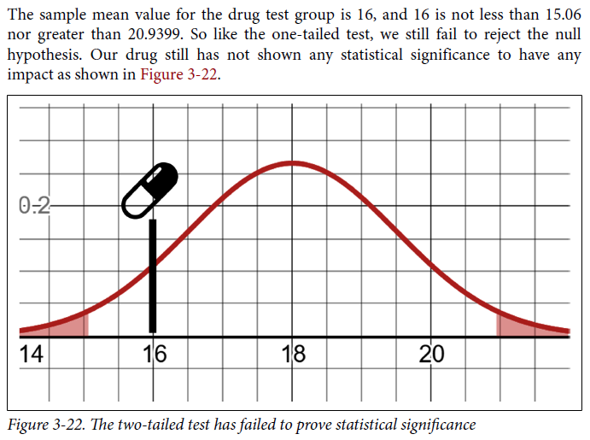

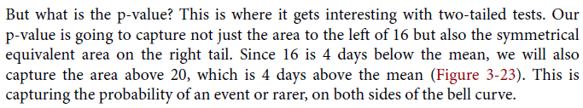

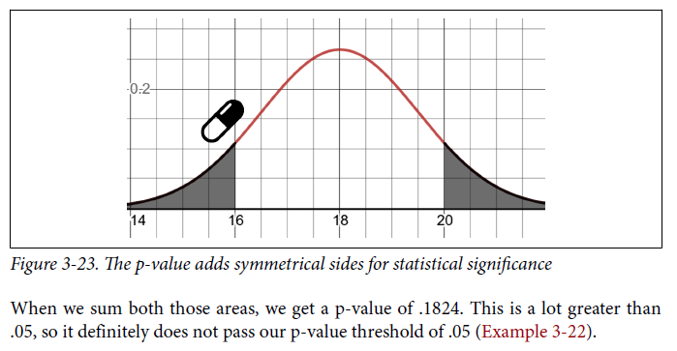

**Calculating the two-tailed p-value in Python:**

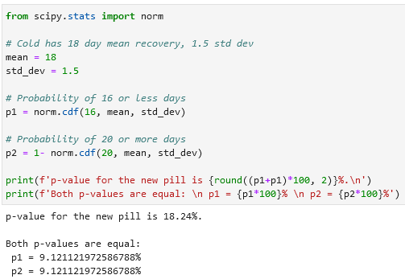

Example 2:

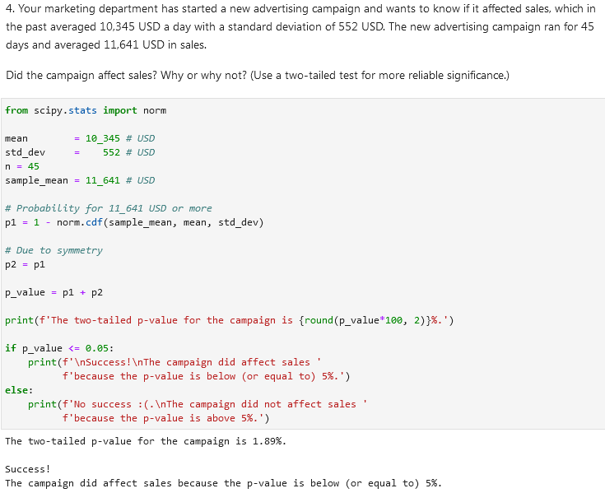

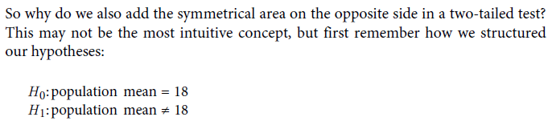

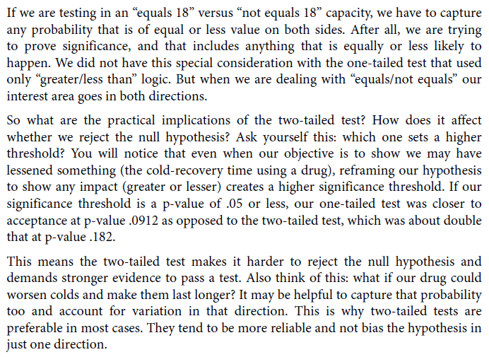

**p-hacking**

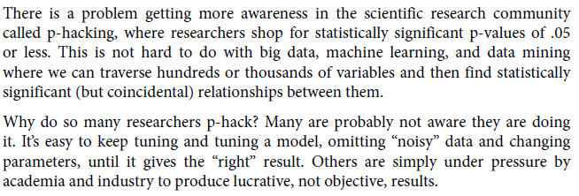

**T-Distribution (dealing with small samples)**

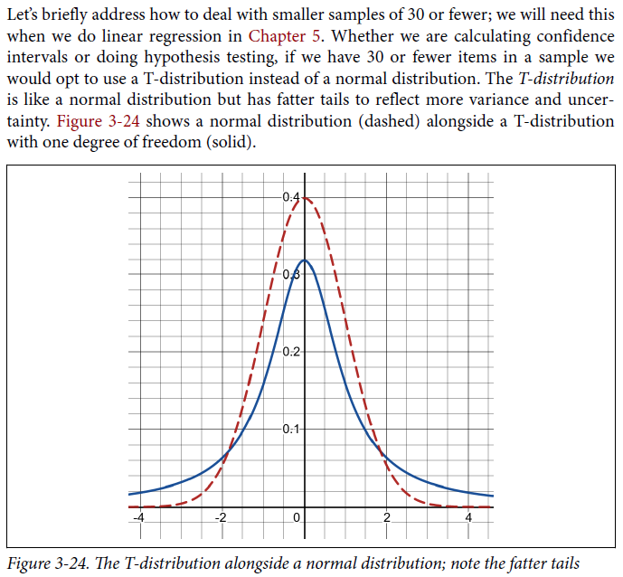

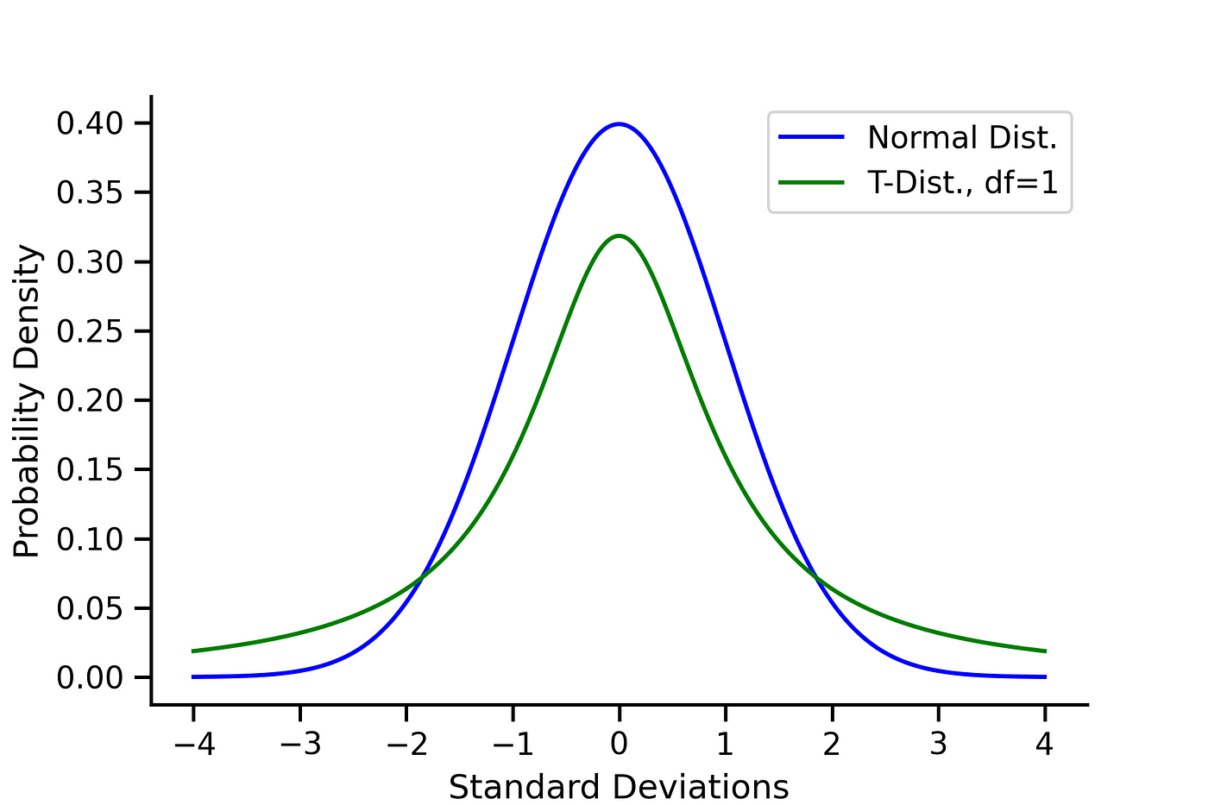

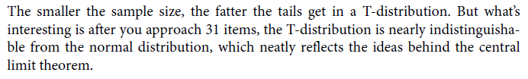

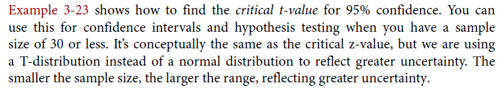

Get a critical value range with a T-distribution in Python using t.ppf:

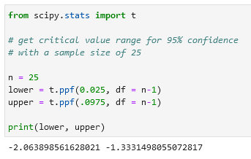



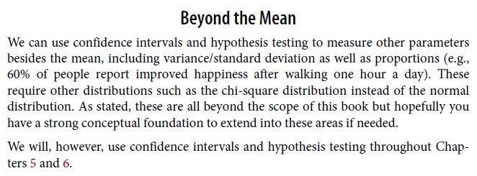

**Big Data Considerations**

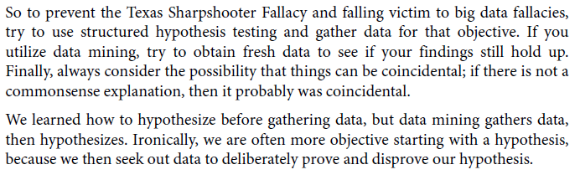

**Linear Algebra**

Linear algebra concerns itself with linear systems but represents them through vector spaces and matrices.

Линейная алгебра занимается линейными системами, но представляет их через векторные пространства и матрицы.

**Vector**

In computer science, it is an array of numbers storing data. В информатике это массив чисел, хранящий данные.

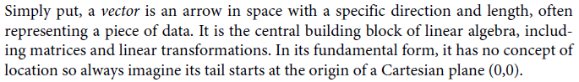

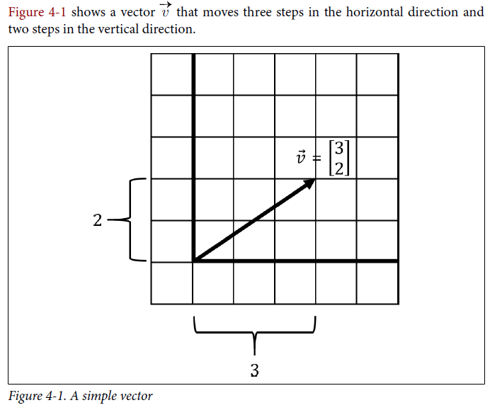

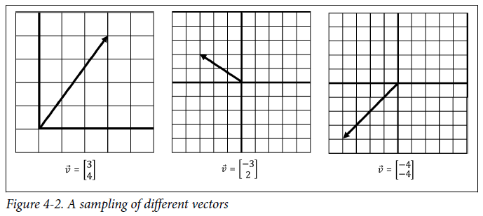

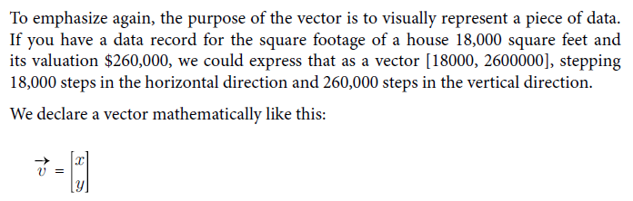

Declaring a vector using a simple Python collection, like a Python list:

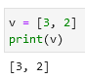

Declaring a vector using NumPy (two-dimensional, three-dimensional, five-dimensional):

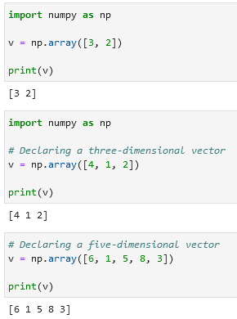

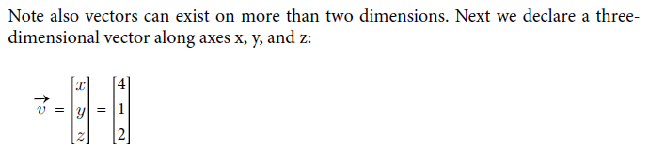

**Computations in Numpy, Python, and SymPy**

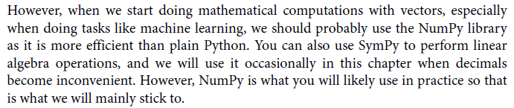

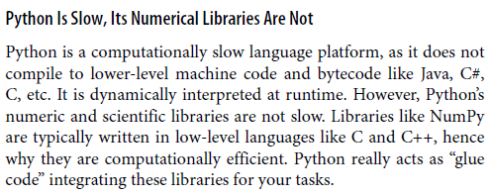

**Vector addition / adding and combining vectors**

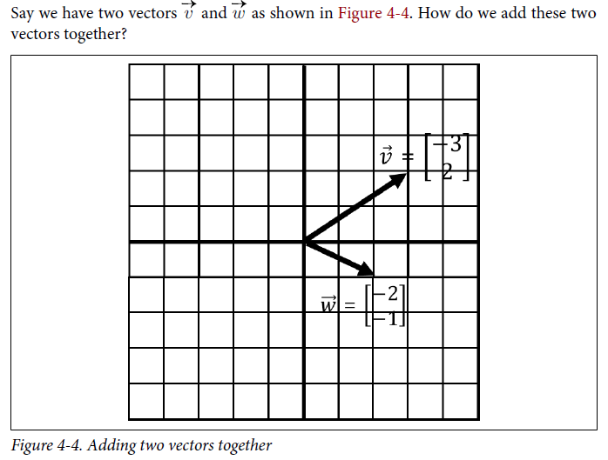

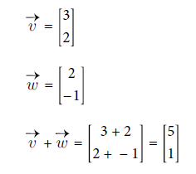

Adding vectors in Python using np.array:

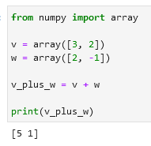

Visually adding two vectors:

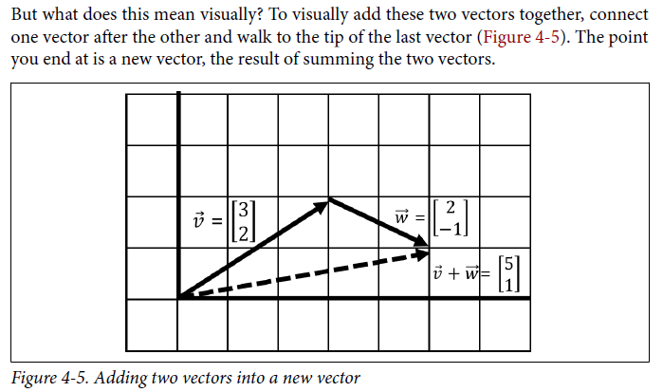

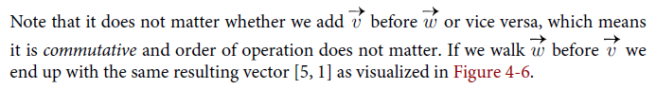

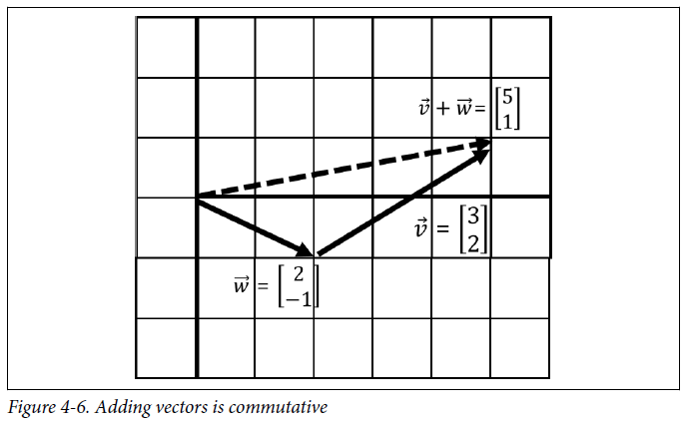

**Scaling vectors**

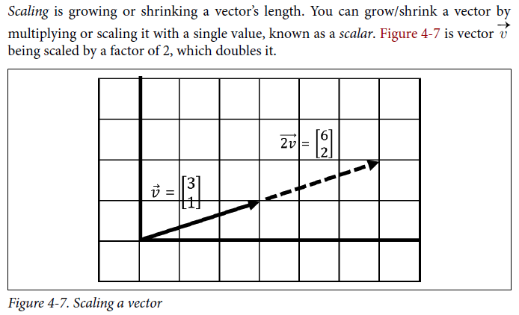

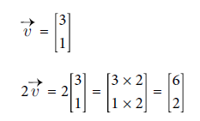

Scaling vectors in NumPy:



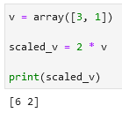

Same is applied as vectors are scaled down (decreased):

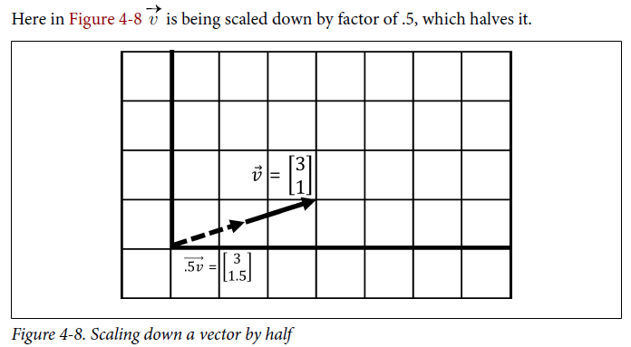

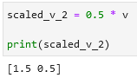

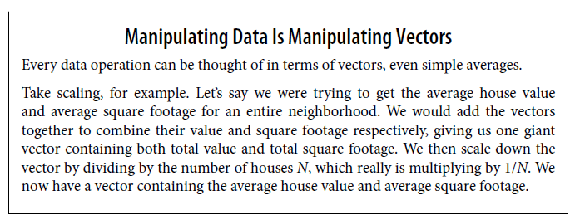

Vector changes direction if multiplied by a negative:

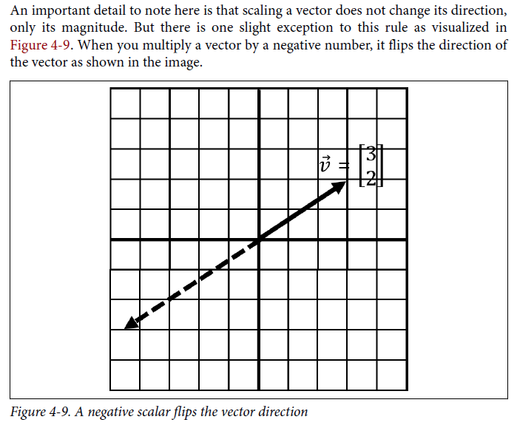

**Linearly dependent vector**

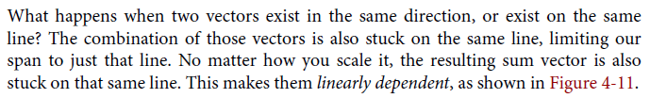

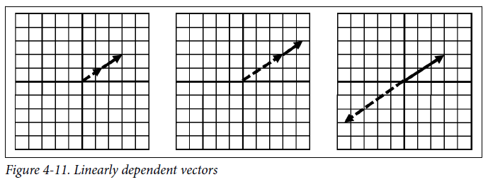

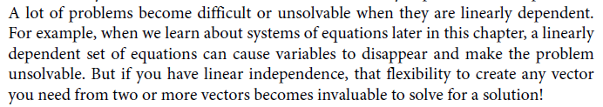

**Linear Transformations**

**Basis Vectors**

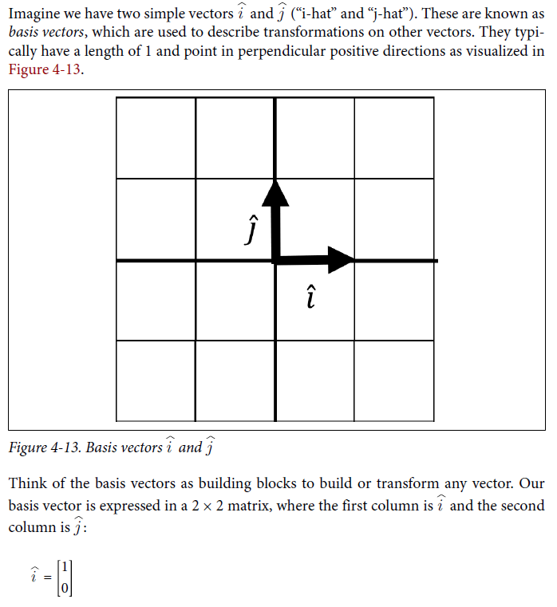

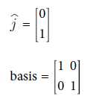

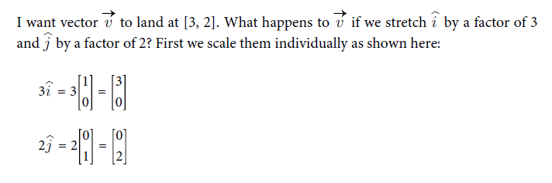

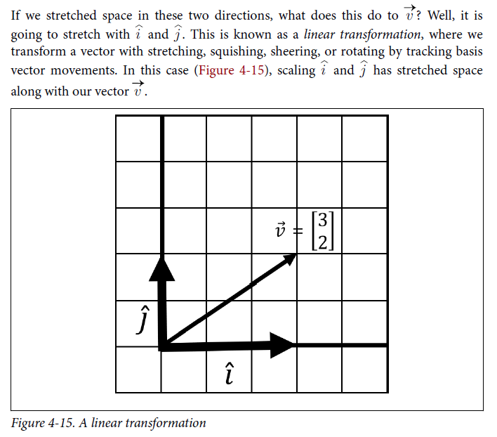linear transformation



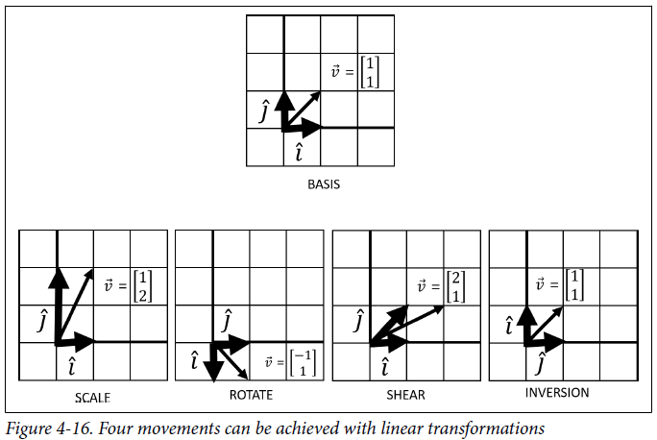

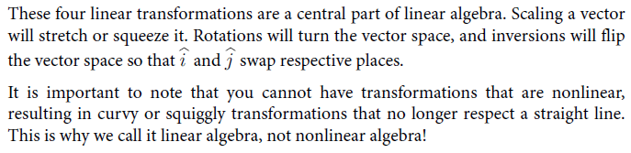

**Matrix Vector Multiplication**



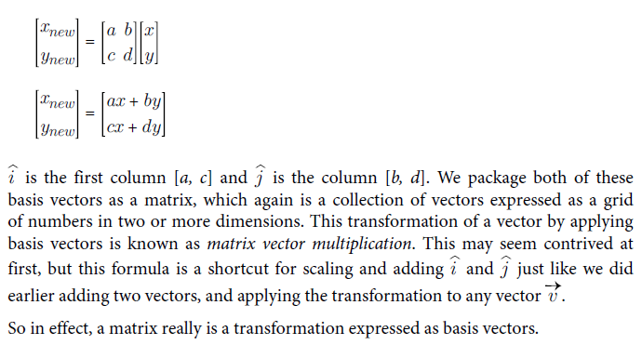

Multiply matrices and vectors in NumPy using .dot():

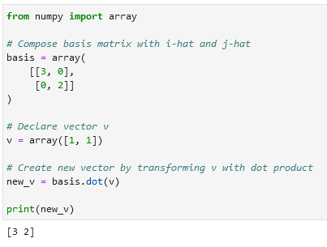

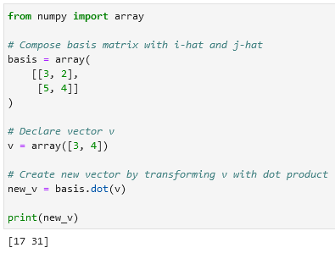← Это не два вектора [3, 2] и [5, 4], а два вектора [3, 5] и [5, 4]. То есть их надо считывать как обычную матрицу визуальную (как на примере внизу). В первой части ты указываешь все координаты всех векторов по *x* ([3, 2]) а во второй координаты всех векторов по *y* ([5, 4]) (see example below from Python).

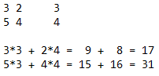

See how two arrays are transformed into one using array() and .transpose():

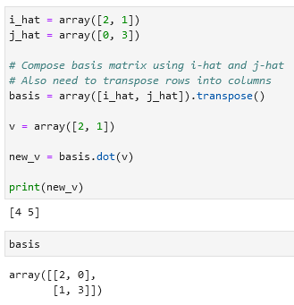

**Matrix multiplication**

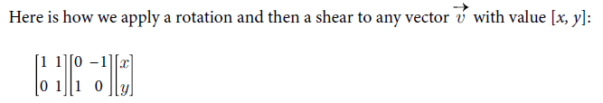

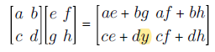

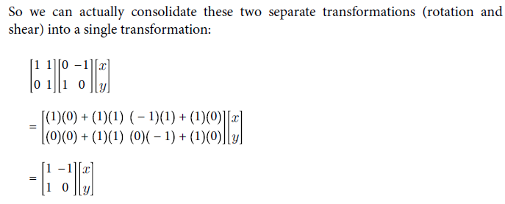

Use np.matmul() or @ to multiple matrices:

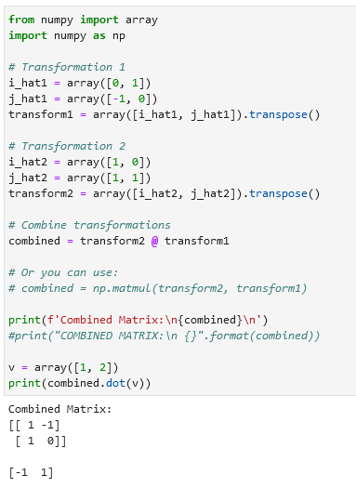

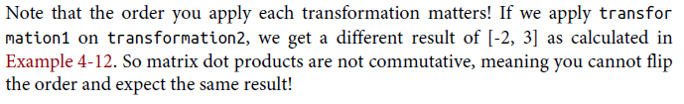

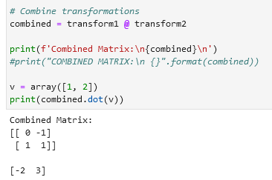

S

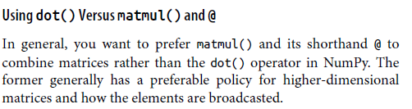dot(), matmul(), @

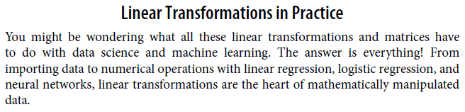

**Determinants**

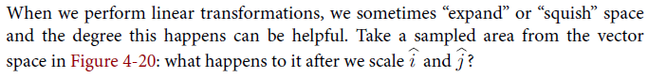

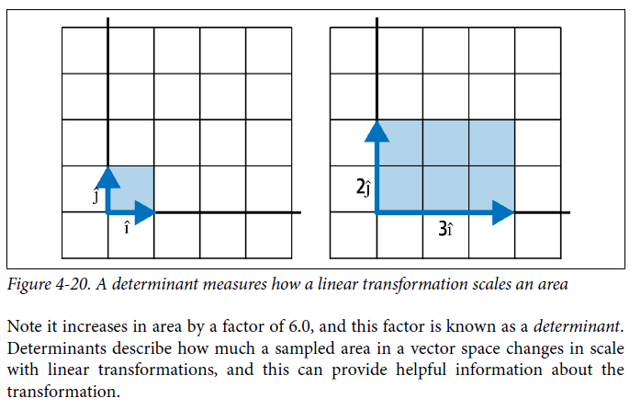

Calculate a determinant using NumPy det():

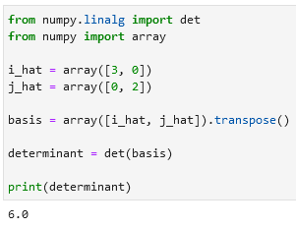

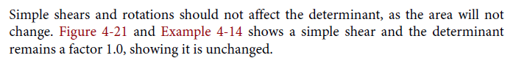

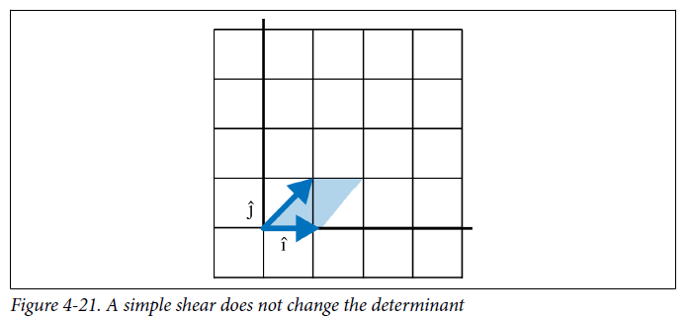

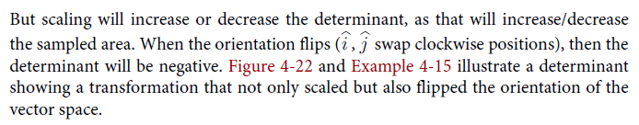

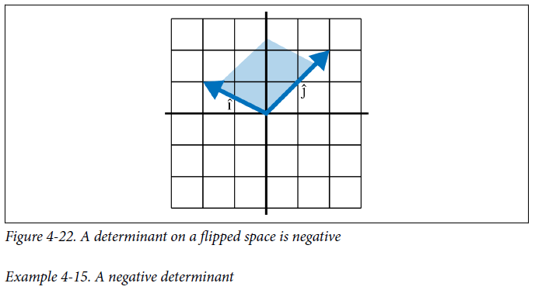

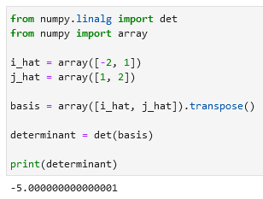

Because this determinant is negative, we quickly see that the orientation has flipped. But by far the most critical piece of information **the determinant tells you is whether the transformation is linearly dependent**. If you have a determinant of 0, that means all of the space has been squished into a lesser dimension.

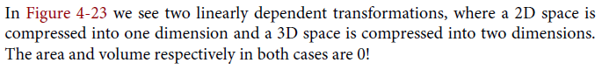

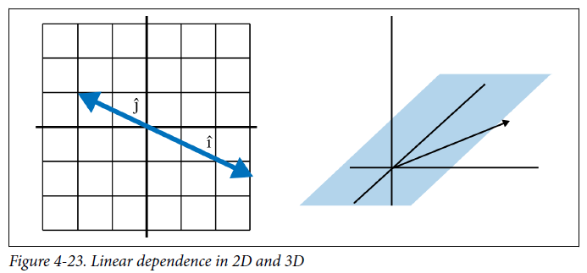

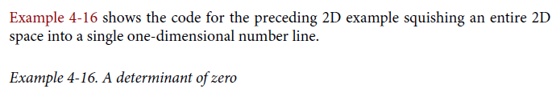

**Check if a determinant is 0 (check for linear dependency):**

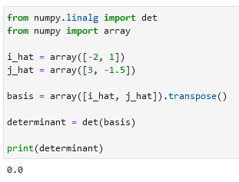

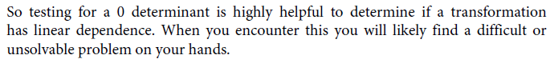

**Special types of matrices**

**Transposed matrix**

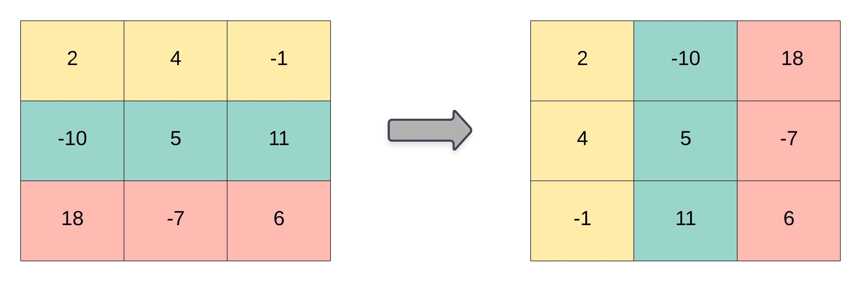

S

**Square matrix**

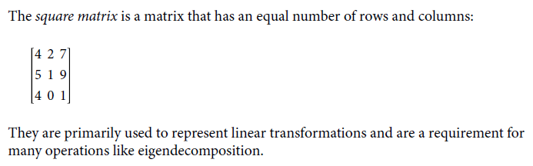

**Identity matrix**

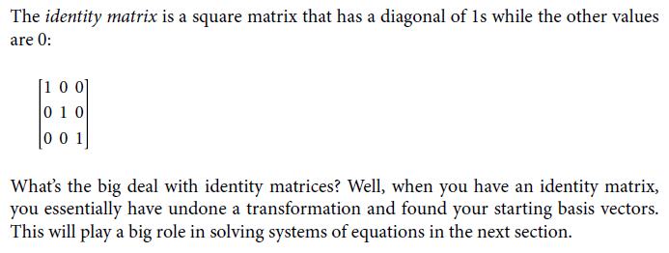

**Inverse matrix**

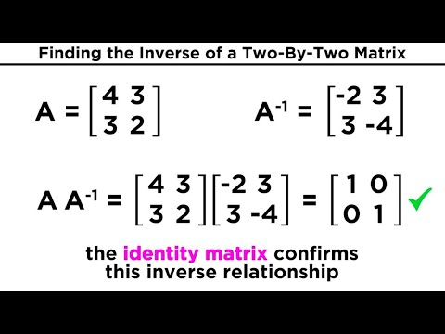

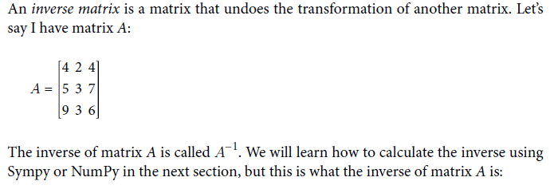

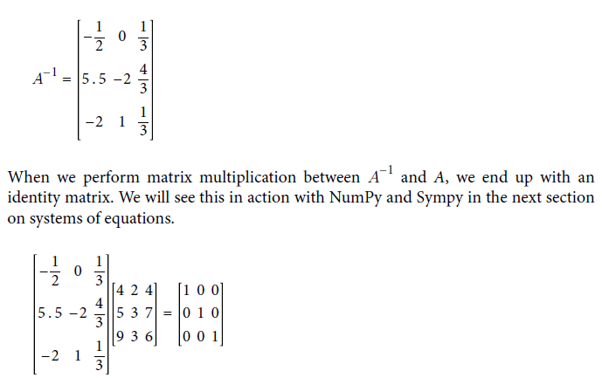

**Diagonal matrix**

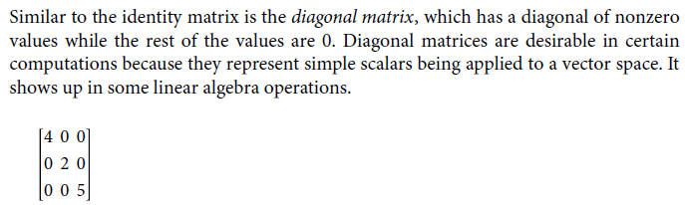

**Triangular matrix**

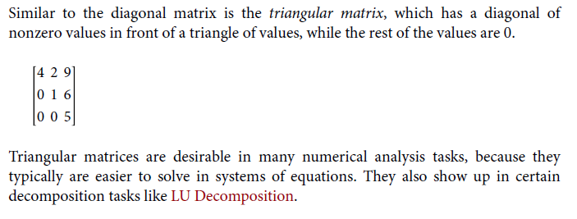 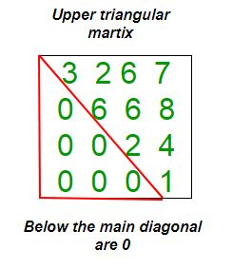

**Sparse matrix**

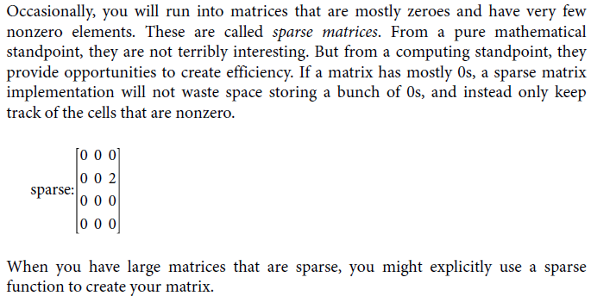

**Systems of Equations and Inverse Matrices**

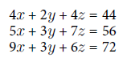

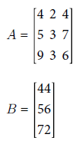

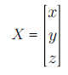

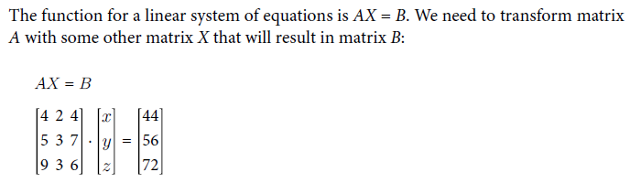

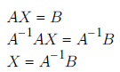

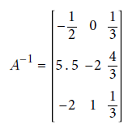

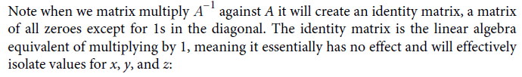

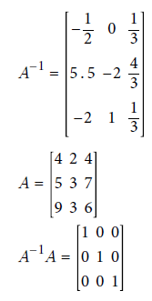

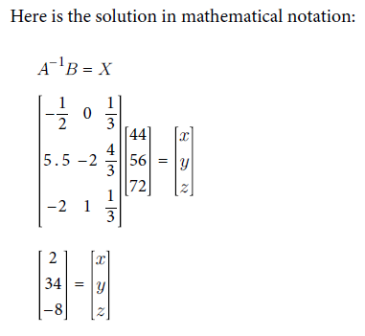

**Getting the inverse and identity matrix in SymPy using Matrix() and .inv():**

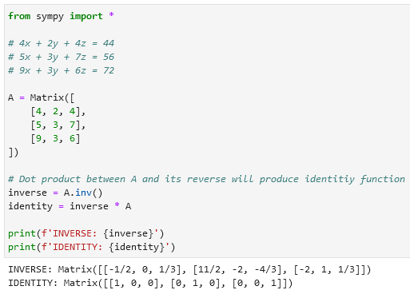

**Use NumPy to solve a system of equations using inv().dot(): Use SymPy to solve a system of equations:**

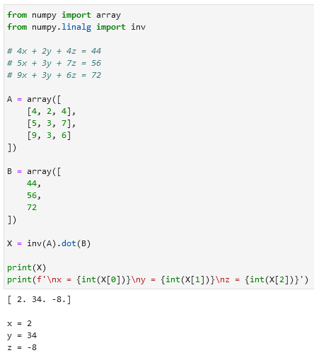 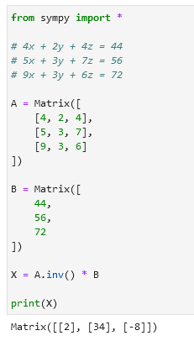

**Eigenvectors and Eigenvalues**

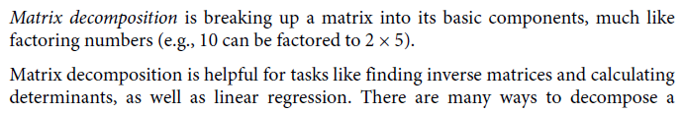



For now, just know eigendecomposition is helpful for breaking up a matrix into components that are easier to work with in different machine learning tasks. Note also it only works on square matrices.

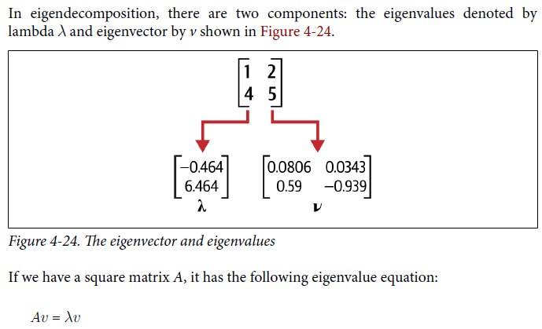

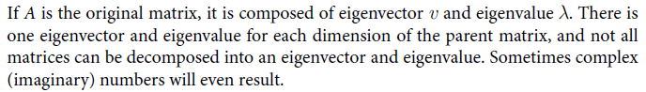

**Calculate eigenvectors and eigenvalues in NumPy for a given matrix A / performing eigendecomposition using eig():**

**Also recompose a matrix using inv() and diag():**

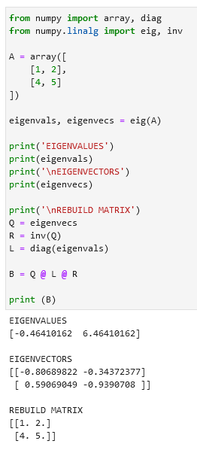

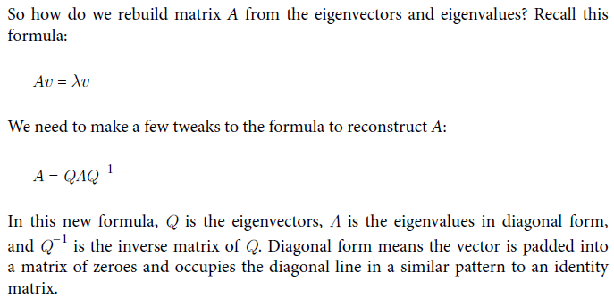

**5. Linear Regression**

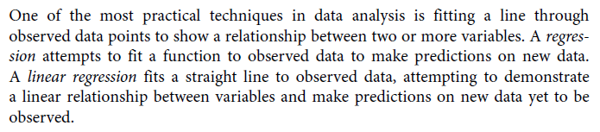



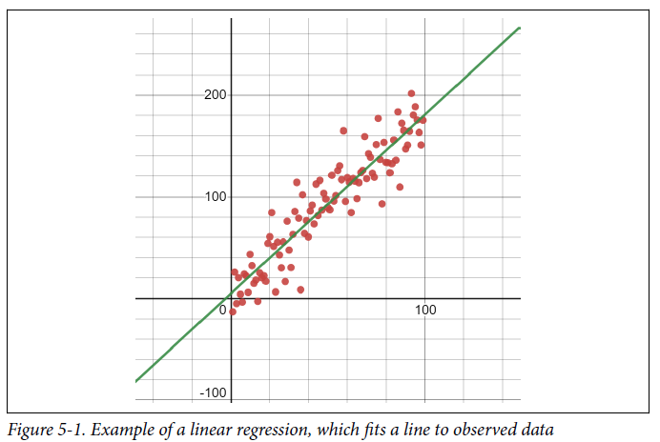

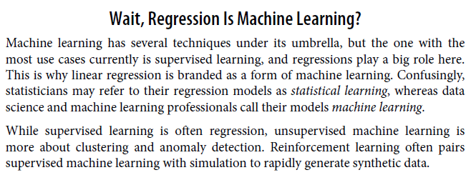

Supervised learning (regressions)

Linear regression = statistical learning or machine learning

Unsupervised machine learning = clustering and anomaly detection

Reinforcement learning = pairs supervised ML with simulation to rapidly generate synthetic data

**A Basic Linear Regression**

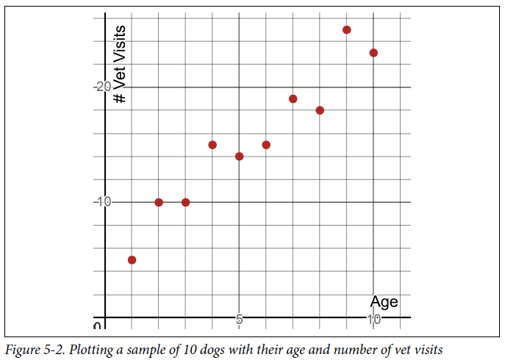

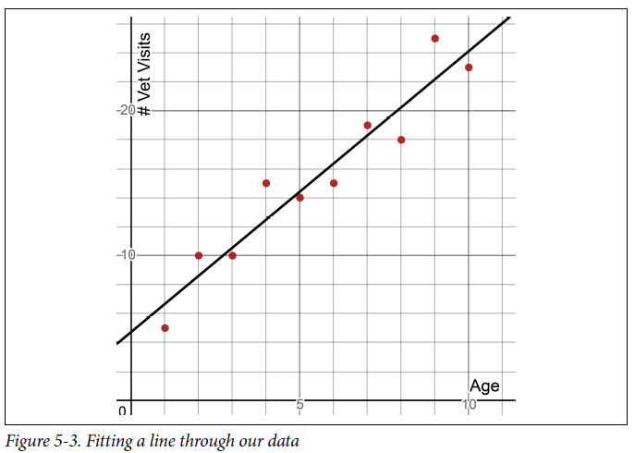

I do not have a dog in my sample that is 8.5 years old, but I can look at this line and estimate the dog will have 21 veterinary visits in its life. I just look at the line where x = 8.5 and I see that y = 21.218 as shown in figure. Another benefit: we can analyze variables for possible relationships and hypothesize that correlated variables are causal to one another.

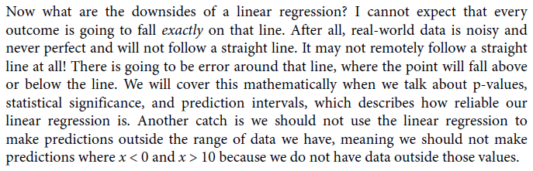

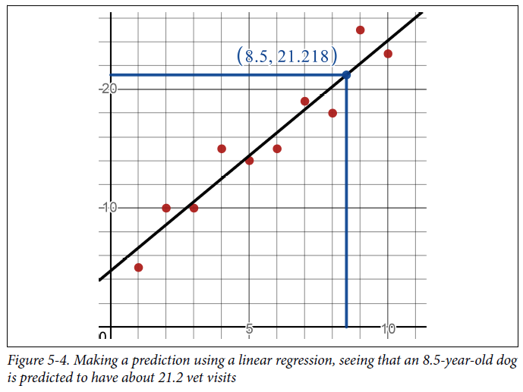

Do a linear regression using pandas, scikit-learn, and Matplotlib using LinearRegression().fit(X, Y) and .coef_.flatten() and intercept_.flatten():

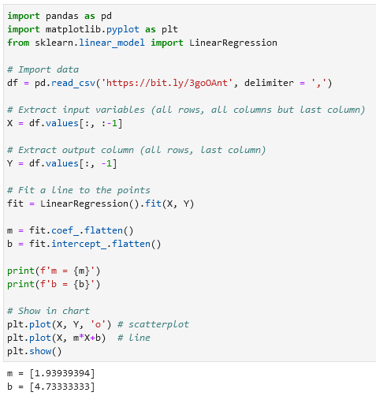

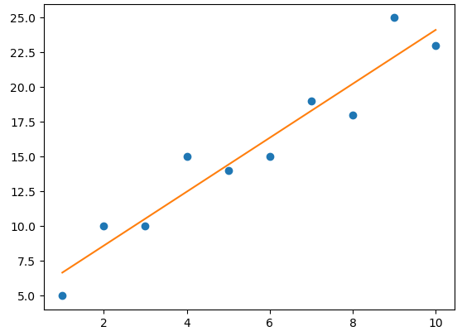

**Residuals and Squared Errors**

**Residuals: differences between the line and the points.**

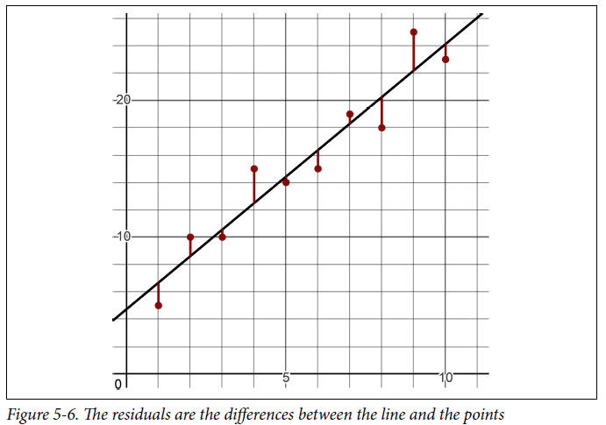

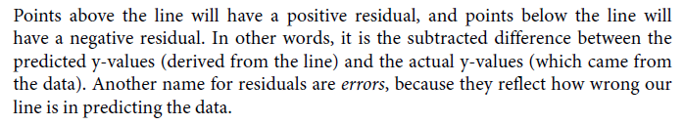another name for residuals are errors

**Calculating the residuals using pandas and .itertuples():**

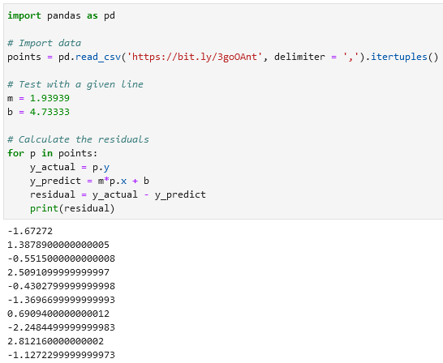

**Sum of squares**

We take each actual y-value and subtract from it the predicted y-value taken from the line, then square and sum all those differences. The lower the sum of square the better the fit.

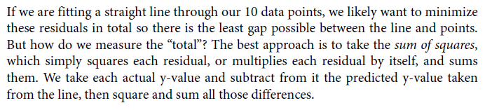

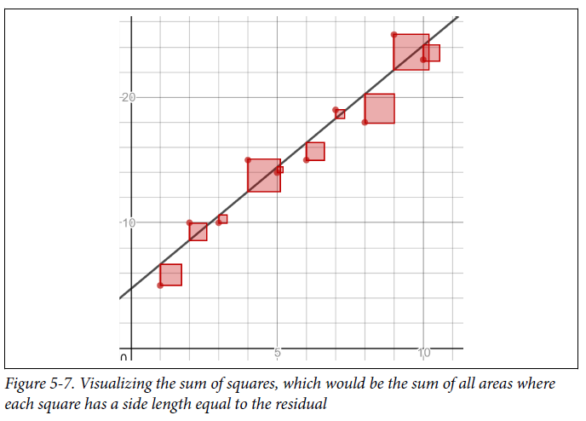

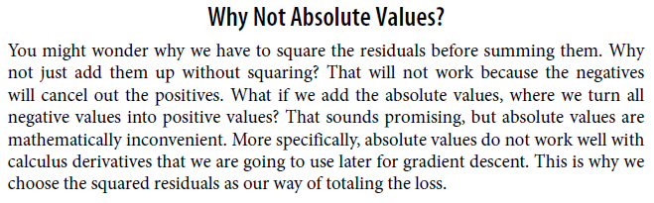

**Calculate sum of squares in pandas:**

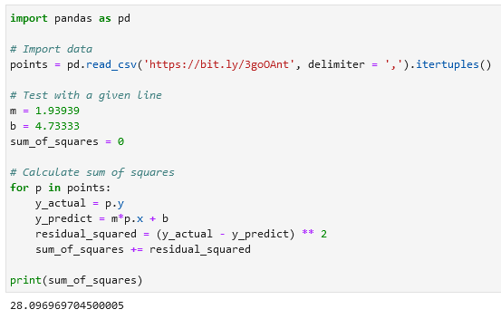

**Finding the Best Fit Line**

How do we find the right *m* and *b* values that create the least *sum of squares*? Five common techniques you can use:

1. Closed form equation,
2. Matrix inversion,
3. Matrix decomposition,
4. Gradient descent,
5. Stochastic gradient descent.

There are other search algorithms like *hill climbing* that could be used, but they are less common.

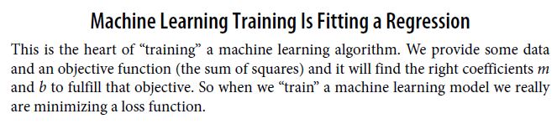

**Closed Form Equation**

For a simple linear regression with only one input and one output variable, here are the closed form equations to calculate *m* and *b*:

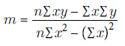 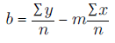

Calculate *m* and *b* using pandas using the Closed Form Equation (calculating *m* and *b* for a simple linear regression):

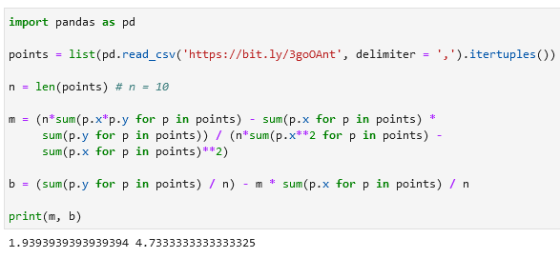

**Computational complexity**

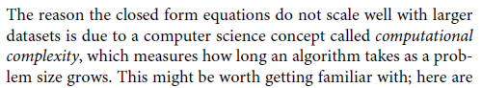

**Inverse Matrix Techniques (matrix inversion)**

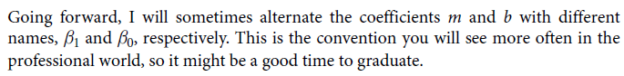

**Slope, intercept, dependent variabЫle and independent variable**

y = m * x + b or y = β1 * x + β0

β0 = intercept

β1 = slope

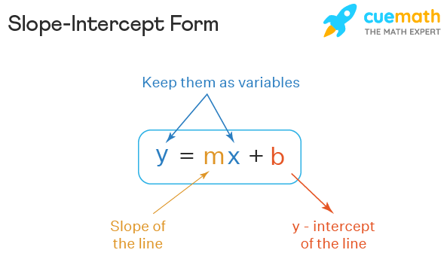

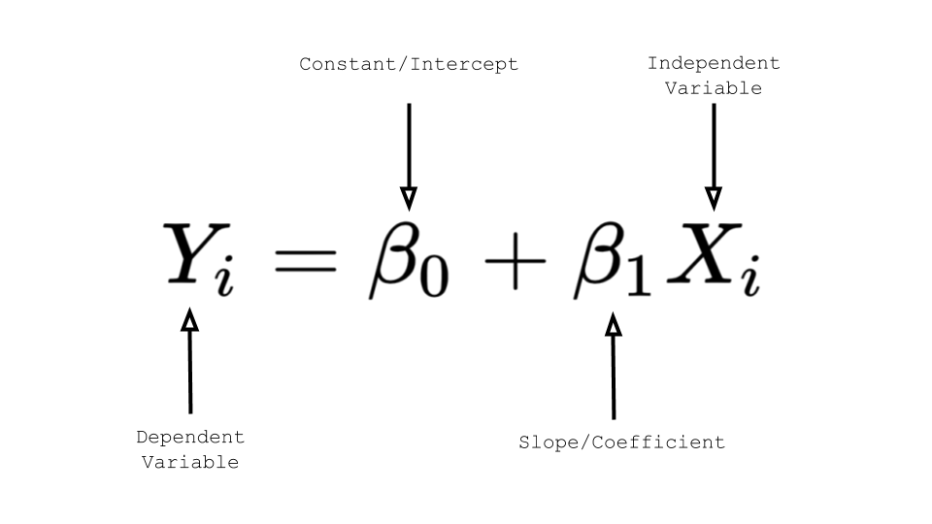

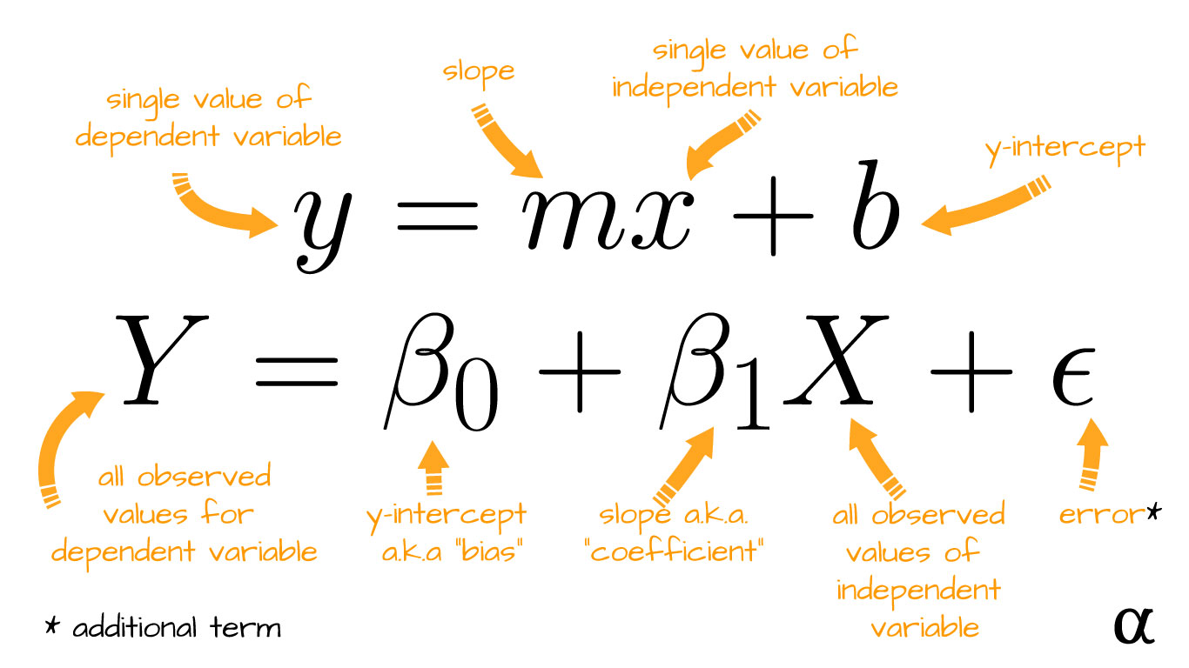

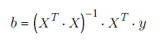

Using inverse and transposed matrices to fit a linear regression:

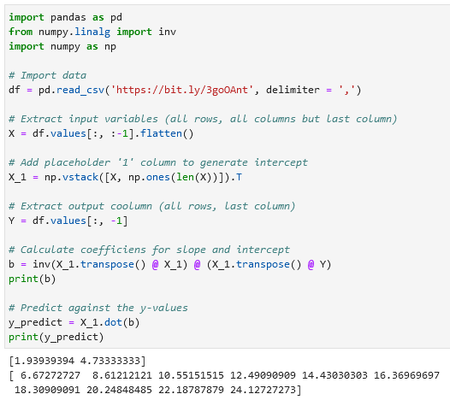

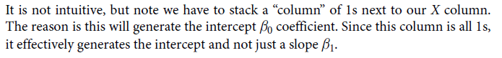

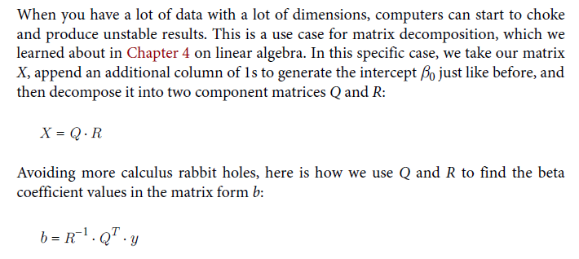

**Using QR decomposition to perform a linear regression in Python:**

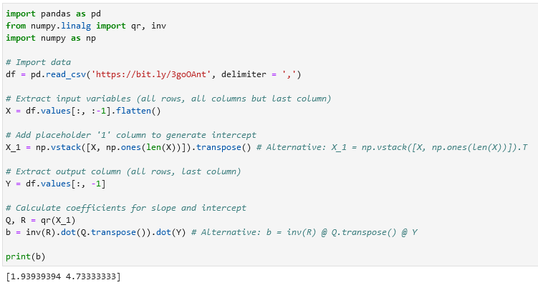

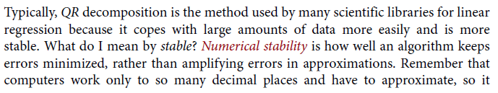



**flatten()**

flatten() is a method used to convert a NumPy array with any number of dimensions into a one-dimensional (1D) array. It essentially collapses all the dimensions of the array into a single dimension, resulting in a flat array. This operation is often used when you want to reshape or reformat data for further processing or analysis.

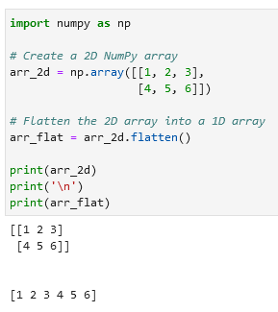

Now all elements are contained in a single row.

**np.vstack np.ones .T**

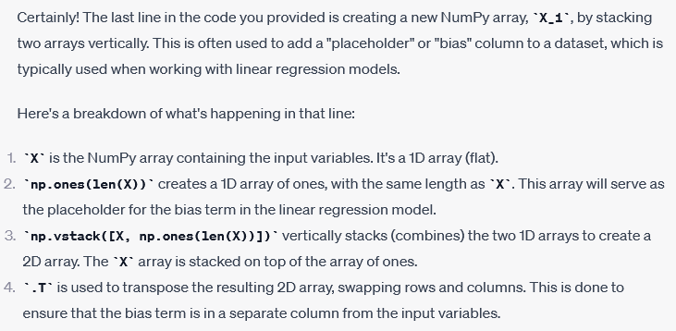

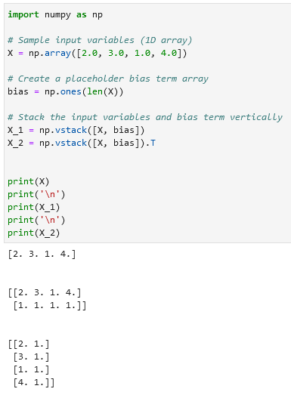

**Gradient descent**

Gradient descent is an optimization technique that uses derivatives and iterations to minimize/maximize a set of parameters against an objective.

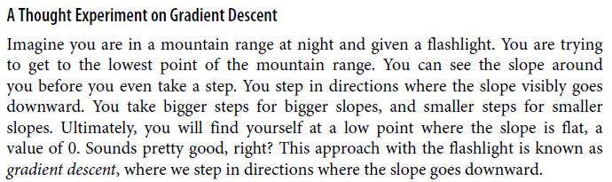

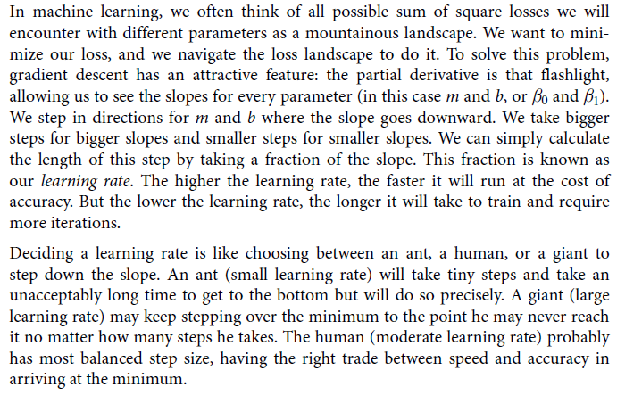

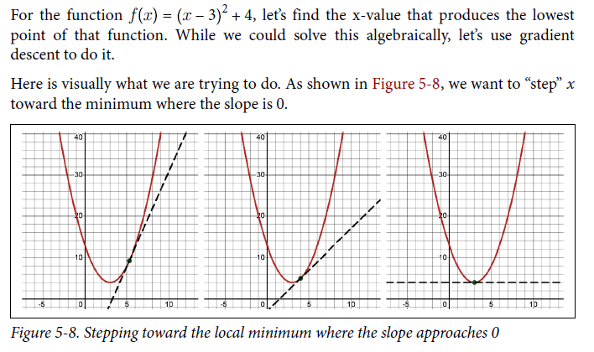

Use gradient descent to find the minimum of a parabola in Python:

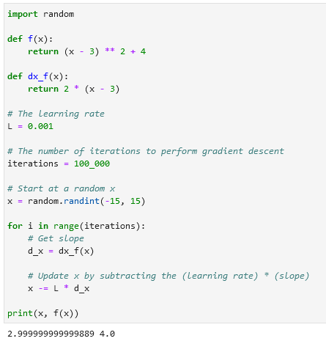

dx_f (derivative) can be calculated using:

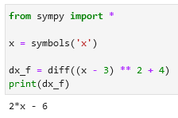

Note that the smaller you make that learning rate, the slower it will be and the more iterations you will need. But if you make it too high, it will run fast but have a poor approximation. When someone says a machine learning algorithm is “learning” or “training,” it really is just fitting a regression like this.

**Performing a gradient descent for a linear regression in Python:**

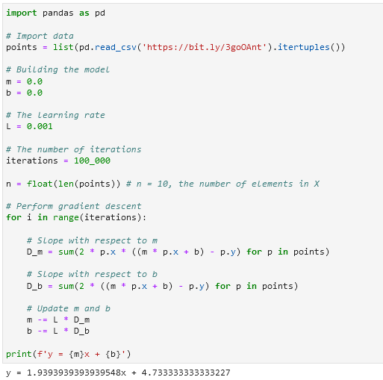 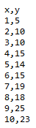

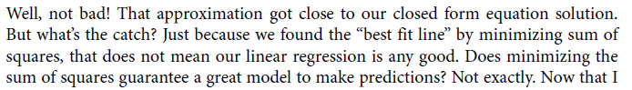

Calculating partial derivatives for m and b in SymPy:

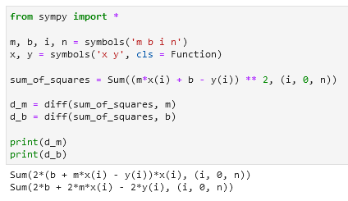

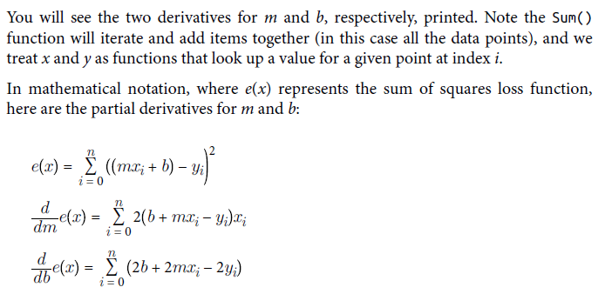

Solving linear regression using SymPy:

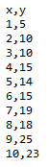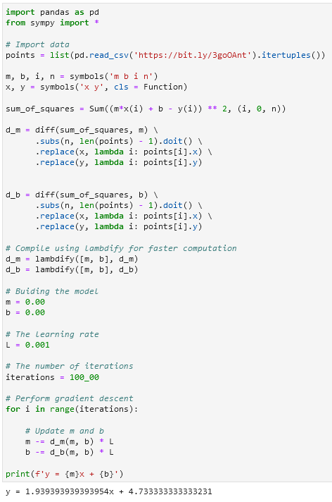lambdify

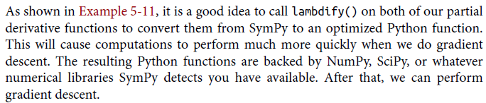

Plotting the loss function for linear regression

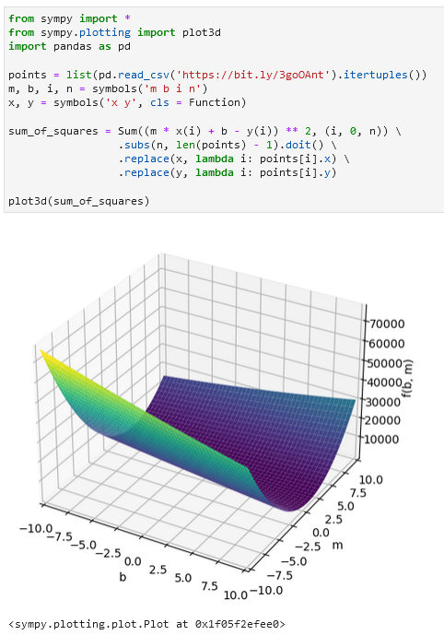

**Overfitting and variance**

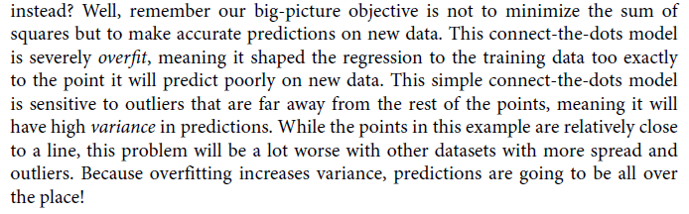

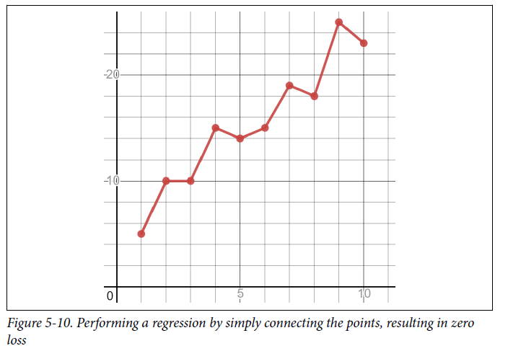

**Overfitting is memorization**

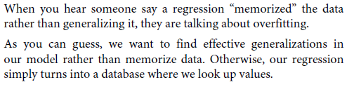

**Bias in a model / biased model**

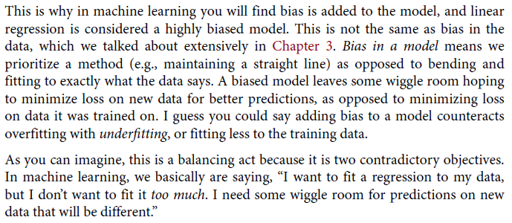

**Lasso and ridge regression**

